**A Massive MIMO Digital Beamforming**

**mm-Wave Transceiver for 5G**

**A Graduation Project Thesis**

**Submitted to**

Electronics & Communications Engineering Department

Faculty of Engineering

Ain Shams University

**Submitted by**

|  |
| --- |
| Asmaa Anwar Hamed Eissa |
| Donia Mohamed Adel Elsaid |
| Jumana Ahmed Mohamed |
| Moamen Khaled Moselhi Mohamed |
| Mohamed Abdallah Ali Mohamed |
| Mohamed Ahmed Fares Zyan |
| Mohamed Hossam Rafik |
| Shady Emad Zaki |
| Yousif Ahmed Ali Mohamed |
| Ziad Ahmed Eped Mohamed |

**Under The Supervision of**

Dr. Micheal Ibrahim

Dr. Theodora Mamdouh

**January 2025**

# Table of Contents

List of Figures ............................................................................................................................4

List of Abbreviations..................................................................................................................6

Abstract.....................................................................................................................................7

Chapter 1: Introduction ...................................................................................................... 8

1.1 Motivation ........................................................................................................................ 8

1.2 Technological advancements ............................................................................................. 9

1.3 Document Breakdown.......................................................................................................11

Chapter 2: Literature Review ………………………………………………………………………………………….12

2.1 MIMO …………………….........................................................................................................12

2.1.1 What is a MIMO system…………...…......................................................................... 12  
 2.1.2 The transition from SISO to MIMO……………………………………………………………….…... 12  
 2.1.3 Why MIMO?........................................................................................................... 14  
 2.1.4 Single-User MIMO……………………………………………………………………………………………… 15  
 2.1.5 Multi-User MIMO……………………………………………………………………………………………….15  
 2.1.6 What is Massive MIMO……………………………………………………………………………………… 17  
 2.1.7 Development of MIMO Technology…………………………………………………………………… 19

2.2 Beamforming ……………………………………………………………………………………………………………….20

2.2.1 What is Beamforming……....................................................................................... 20  
 2.2.2 Beamforming in MIMO systems….......................................................................... 20  
 2.2.3 Benefits of beamforming…………………………………………………………………………………… 21  
 2.2.4 Beamforming techniques and types………………………………………………………………….. 22

2.3 Digital Beamforming …………………………………………………………………………………………………… 25

2.3.1 Phased Arrays…….…………....................................................................................... 25  
 2.3.2 Steering vector………………………………………………………………………………………………….. 29  
 2.3.3 Delay and Sum Beamformer...……………….………………………………………………………….. 31  
 2.3.4 MVDR/Capon Beamformer……………………………………………………………………………….. 33  
 2.3.5 LCMV Beamformer……………………………………………………………………………………………. 36  
 2.3.6 Subspace Techniques………………………………………………………………………………………… 37  
 2.3.6.1 MUSIC…………………………………………………………………………………………………….. 37  
 2.3.6.2 ESPRIT…………………………………………………………………………………………………….. 38

Chapter 3: MATLAB Implementation & Simulation........................................................... 41

3.1 Delay and sum........................................................................................................... 41   
 3.2 MVDR ………………………………………………………………………………………………………………….. 44  
 3.3 Delay and sum vs MVDR comparison …………………………………………………………………… 46  
 3.4 LCMV …………………………………………………………………………………………………………………… 48  
 3.5 MUSIC …………………………………………………………………………………………………………………. 49  
 3.6 ESPRIT …………………………………………………………………………………………………………………. 52

Chapter 4: Conclusion and Future Work .......................................................................... 54

4.1 Conclusion……………………………………………………………………………………………………………. 54  
 4.2 Future work …………………………………………………………………………………………………………. 55

References ..............................................................................................................................59

# List of Figures

Figure 1 - Number of connected devices and data traffic from 2016 to 2022

Figure 2 – MIMO antenna system

Figure 3 – SISO implementation

Figure 4 – SIMO implementation

Figure 5 – MISO implementation

Figure 6 – MIMO implementation

Figure 7 – MIMO as a receiver

Figure 8 – MIMO as a transmitter

Figure 9 – SU-MIMO

Figure 10 – MU-MIMO

Figure 11 – MU-MIMO uplink channel

Figure 12 – MU-MIMO downlink channel

Figure 13 – Massive MIMO downlink channel

Figure 14 – Antenna configuration for the LTE technologies

Figure 15 – Beamforming Example

Figure 16 – Beamforming antenna array Vs Sectored antenna array

Figure 17 – Beamforming array

Figure 18 – Beamforming Techniques

Figure 19 – Analog Beamforming Receiver

Figure 20 – Digital Beamforming Receiver

Figure 21 – Hybrid Beamforming Receiver

Figure 22 – Antenna array model

Figure 23 – Single isotropic antenna radiation pattern

Figure 24 – Two isotropic antennas radiation pattern

Figure 25 – Two isotropic antennas radiation pattern (zoomed out)

Figure 26 – Two isotropic antennas with spacing $λ$ radiation pattern

Figure 27 – Three isotropic antennas radiation pattern

Figure 28 – Two isotropic antennas with phase shift radiation pattern

Figure 29 – Eight isotropic antennas with beam steering

Figure 30 – ULA

Figure 31 – Delay calculation

Figure 32 – Delay and sum beamforming

Figure 33 – Decomposing the network into two sub-networks

Figure 34 – Transmitted signal

Figure 35 – Received signals at the ULA

Figure 36 – Delay and sum beamformed signal

Figure 37 – Delay and sum DOA metric rectangular plot

Figure 38 – Delay and sum DOA metric polar plot

Figure 39 – MATLAB DOA calculation

Figure 40 – Transmitted signal

Figure 41 – Received signals at the ULA

Figure 42 – MVDR beamformed signal

Figure 43 – MVDR DOA metric rectangular plot

Figure 44 – MVDR DOA metric polar plot

Figure 45 – MATLAB DOA calculation

Figure 46 – Delay and sum Vs MVDR DOA metric rectangular plot

Figure 47 – Delay and sum Vs MVDR DOA metric polar plot

Figure 48 – LVMV DOA metric rectangular plot

Figure 49 – LCMV DOA metric polar plot

Figure 50 – MUSIC DOA metric rectangular plot

Figure 51 – MUSIC DOA metric polar plot

Figure 52 – MUSIC number of input signals estimation

Figure 53 – Underestimating the number of input signals

Figure 54 – Overestimating the number of input signals

Figure 55 – MUSIC for closely separated signals

Figure 56 – ESPRIT DOAs MATLAB calculation

Figure 57 – MUSIC & ESPRIT DOA metric

Figure 58 – Rx-block diagram

Figure 59 – DDC before adding the interleaver

Figure 60 – DDC after adding the interleaver

Figure 61 – Uniform Linear Array with signal wavefront

Figure 62 – Decimation Filter

Figure 63 – Interpolation vs Decimation

# List of Abbreviations

|  |  |
| --- | --- |
| mm-Wave | Millimeter wave |
| MIMO | Multiple input multiple output |
| SISO | Single input single output |
| SIMO | Single input multiple output |
| MISO | Multiple output single input |
| SU-MIMO | Single-user Multiple input multiple output |
| MU-MIMO | Multi-user Multiple input multiple output |
| OFDM | Orthogonal Frequency Division Multiplexing |
| RF | Radio Frequency |
| ULA | Uniform linear array |
| AOA | Angle of arrival |
| DOA | Direction of arrival |
| SOI | Signal of interest |

**Abstract**

There are **three timeless truths** in the field of wireless communications:

* Demand for wireless throughput, both mobile and fixed, **will always increase**.
* The available electromagnetic spectrum **will never increase**, and the most desirable frequency bands that can propagate into buildings and around obstacles and that are unaffected by weather **constitute only a small fraction of the entire spectrum**.
* Communication theorists and engineers will always be pressured to invent or to discover breakthrough technologies that **provide higher spectral efficiency**. [1]

To address these challenges we will investigate both **MIMO** systems and **Beamforming** **tecniques**.

**MIMO** is considered a breakthrough technology in the area of wireless communication because it achieves an increase in data rates, channel capacity and spectral efficiency by constructing base stations with large number of antennas that simultaneously communicate with multiple spatially separated user terminals over the same frequency resource and exploit multipath propagation.

**Beamforming** is a signal processing technique to steer, shape, and focus signals using an array of antennas toward a desired direction. It’s used to increase SNR of the desired signals, null out interferers, shape beam patterns, or even transmit/receive multiple data streams at the same time and frequency.

**Ch 1: Introduction**

**1.1 Motivation**

Wireless communication technology has fundamentally changed the way we communicate. The time when telephones, computers, and Internet connections were bound to be wired, and only used at predefined locations, has passed. These communications services are nowadays wirelessly accessible almost everywhere on Earth, thanks to the deployment of cellular wide area networks (e.g., based on the GSM1, UMTS2, and LTE3 standards), local area networks (based on different versions of the Wi-Fi standard IEEE 802.11), and satellite services.

Wireless connectivity has become an essential part of the society—as vital as electricity—and as such the technology itself spurs new applications and services. We have already witnessed the streaming media revolution, where music and video are delivered on demand over the Internet. The first steps towards a fully networked society with augmented reality applications, connected homes and cars, and machine-to-machine communications have also been taken. Looking 15 years into the future, we will find new innovative wireless services that we cannot predict today.

The motivation for this project arises from the critical need to address the limitations and challenges faced by current wireless communication systems.

As the demand for higher data rates, increased capacity and improved user experience continues to grow existing technologies are increasingly struggling to meet these requirements.

Several key factors drive the motivation for integrating **Massive MIMO**, **Beamforming**, and **mm-Wave** technologies into modern wireless networks.

**Increased demand for higher data rates and capacity**

One of the main drivers of wireless communication system growth is the demand for higher data rates and capacity from users and applications. With the proliferation of smartphones, tablets, laptops, and other devices, the wireless traffic is expected to grow exponentially in the coming years. Moreover, new applications such as video streaming, online gaming, cloud computing, and virtual reality require higher bandwidth and lower latency than traditional voice and text services.

Industry projections indicate that global mobile data traffic will continue to grow at a rapid pace. Meeting these future demands necessitates advancements in wireless technology that can offer significantly higher capacity and throughput.

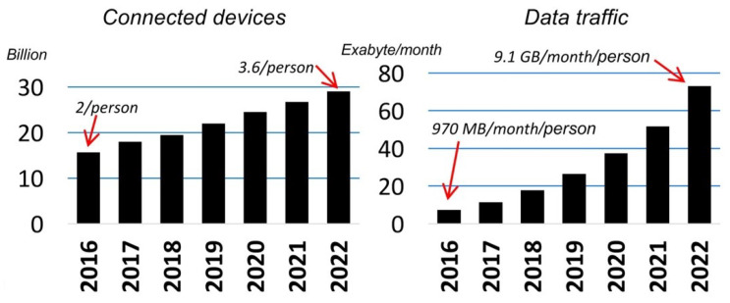

Figure 1 - number of connected devices and data traffic from 2016 to 2022 [[Source](https://pmc.ncbi.nlm.nih.gov/articles/PMC7284607/)]

To meet these requirements, wireless communication systems need to adopt advanced technologies such as multiple-input multiple-output (MIMO), orthogonal frequency-division multiplexing (OFDM), and beamforming, as well as explore new frequency bands such as millimeter wave (mm-Wave) and terahertz (THz).

**Increased demand for more spectral efficiency**

• Limited Spectrum Availability:

The radio frequency spectrum is a finite resource, and the lower frequency bands (sub-6 GHz) commonly used for wireless communications are becoming increasingly congested. This congestion limits the available bandwidth for new services and applications.

• Higher Frequencies:

The underutilized mm-Wave spectrum (30-300 GHz) offers a vast amount of bandwidth, which can be leveraged to alleviate spectrum scarcity and provide high data rates. However, mm-Wave signals have different propagation characteristics and require new approaches to be effectively utilized.

* + 1. **Technological advancements**

**MIMO**

**Multiple-input-multiple-output** communication technology is a breakthrough in wireless communication that has provided greater scalability and the ability to serve more users with lower latency services.

In its infancy, MIMO was an innovative technology that employed multiple antennas at both transmitting and receiving ends to increase the data transfer capacity. However, with the addition of multiplexing techniques like OFDM, antenna arrays using MIMO techniques are used for simultaneously transmitting and receiving multiple data streams over the same radio channel, which is aided by multipath propagation.

**Spatial Multiplexing**

Spatial multiplexing involves sending multiple spatial streams through multiple antennas, and these streams are separated at the receiver through spatial processing. Since the receiver decodes the transmitted streams individually, data throughput can be increased for a fixed channel bandwidth. MIMO spatial multiplexing has the ability to boost spectral efficiency without significantly diminishing the link's robustness. However, diversity gain is lost in this technique.

**Beamforming**

The use of beamforming in MIMO communications involves focusing a signal in a particular direction so that the greatest possible gain is achieved at the receiving end. There are three beamforming techniques:

* Analog, which would be performed with a phased array
* Digital, which uses precoding with modulated data streams to construct a beam pattern
* Hybrid, where analog and digital are combined and multiplexed spatially/temporally

Different beamforming methods used with spatial multiplexing/diversity will require different signal processing methodologies to precode and decode signals. This would need to be implemented with a specialty chipset or an FPGA.

**Single-User (SU) and Multi-User MIMO**

SU-MIMO supports a single device at a time by using radio communication layers from multiple antennas. To achieve the highest possible user spectral efficiency, SU-MIMO transmissions utilize time-frequency resources that are exclusively allocated to a single user device. MU-MIMO, on the other hand, allocates multiple users to a single time-frequency resource. This is a significant advantage as compared to SU-MIMO, particularly in channels with spatial correlation.

**OFDM in MIMO Communication**

OFDM is a form of multicarrier modulation in which data is sent at a reduced rate using parallel subcarriers. The data is first split and superimposed onto numerous frequency carriers prior to transmission, and then it is merged at the receiving end. Uniting MIMO and OFDM leads to an increase in spectral efficiency as spatial multiplexing gain offered by MIMO is used in combination with multi-carrier modulation. The diversity gain achieved by MIMO technology can also increase connection stability and provide a high quality of service (QoS). The practical implementation of OFDM MIMO is no longer as complex as it could have been thanks to advances in baseband digital signal processing and VLSI technology.

**Reconfigurable antennas in MIMO**

Reconfigurability adds flexibility to a MIMO communication system and significantly improves transmission throughput. Polarization, frequency, and radiation patterns are fixed in the case of conventional MIMO antennas. In contrast, reconfigurable antennas can serve as a booster for MIMO systems because their radiation properties (polarization, radiation pattern, frequency) can be reconfigured in response to environmental and system changes. [14]

**1.3 Document Breakdown**

**This document is divided into four chapters:**

**Chapter one**, the introduction, discusses the motivation behind this project, emphasizing the increased demand for higher communication speeds and the technological advancements that enable the use of Massive MIMO and beamforming in modern communication systems.

**Chapter two** is a literature review that explores MIMO systems, their functionality, and the development of MIMO technology. It provides a general explanation of beamforming, highlighting its benefits, various types, and approaches. It then focuses on digital beamforming, starting with phased arrays and steering vector explanations before detailing how different digital beamforming techniques, such as delay-and-sum, MVDR, LCMV, MUSIC, and ESPRIT, operate.

**Chapter three** covers the MATLAB modelling and simulations of these digital beamforming techniques. It outlines the parameters and equations used in the simulations, along with the resulting values and figures.

**Chapter four** and final chapter addresses the future work of this project, including the proposed Rx system. It provides a brief overview of each block in the system and explains their respective functionalities.

**Ch 2: Literature Review**

**2.1 MIMO**

**2.1.1 What is a MIMO system?**

MIMO stands for Multiple-Input Multiple-Output. A MIMO antenna is an antenna system that uses multiple antennas to transmit and receive data simultaneously, thereby increasing the capacity and performance of wireless communication systems.

In a MIMO antenna system, the transmitter and receiver are equipped with multiple antennas. These antennas are strategically placed to create multiple spatial channels for data transmission. Each antenna in the transmitter sends a different copy of the data simultaneously, and each antenna in the receiver receives the copies of the data. The receiver then combines these received signals to improve the signal quality and increase the data throughput. [6]

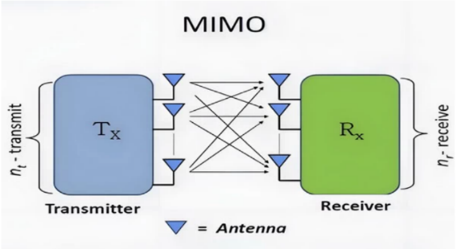

Figure 2 – MIMO antenna system [[Source](https://www.sannytelecom.com/mimo-antennas-vs-siso-antennas/)]

**2.1.2 The transition from SISO to MIMO**

**SISO** provides a unique path between the Tx and Rx antennas and transmits one signal. In a wireless system, each signal is transmitted over one spatial stream. Apparently, such transmission is **unreliable** and **rate limited.**

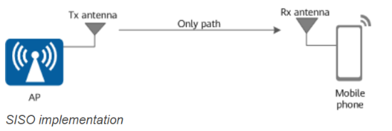

Figure 3 – SISO implementation [[Source](https://info.support.huawei.com/info-finder/encyclopedia/en/MIMO.html)]

To achieve higher **reliability**, **SIMO** and **MISO** are introduced:

Single-input multiple-output (SIMO). That is, one antenna is added on the receiver, as shown in the figure, so that two signals can be received concurrently. Two signals containing the same data are sent from one Tx antenna. If one signal is partially lost, the receiver may still obtain complete data from the other signal. Although the capacity remains unchanged (still one path in use), the reliability is doubled. This mode is also known as **receive diversity**.

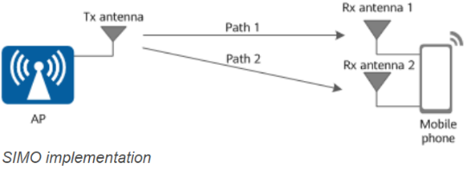

Figure 4 – SIMO implementation [[Source](https://info.support.huawei.com/info-finder/encyclopedia/en/MIMO.html)]

Multiple-input single-output (MISO) is introduced. That is, using two Tx antennas while retaining one Rx antenna. Given the presence of only one Rx antenna, the signals sent from the two Tx antennas must carry the same data and be combined as one signal on the receiver. This mode, referred to as **transmit diversity**, actually delivers the same effect as SIMO.

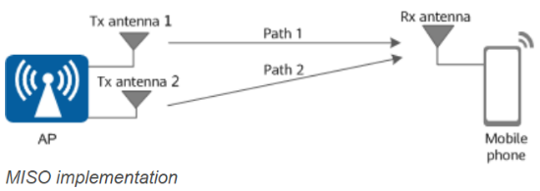

Figure 5 – MISO implementation [[Source](https://info.support.huawei.com/info-finder/encyclopedia/en/MIMO.html)]

The preceding analysis on SIMO and MISO proves that the **transmission capacity depends on the number of Tx and Rx antennas.** Therefore, using two antennas on both the transmitter and receiver can definitely double the rates by transmitting and receiving two signals separately. This mode of using multiple antennas on both the transmitter and receiver is MIMO. [7]

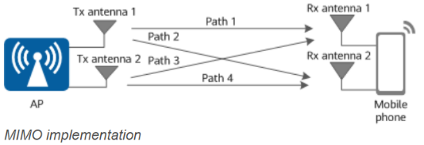

Figure 6 – MIMO implementation [[Source](https://info.support.huawei.com/info-finder/encyclopedia/en/MIMO.html)]

**2.1.3 Why MIMO?**

**MIMO** can be used to increase spectral efficiency, chnnel capacity and link reliability by:

* **Spatial multiplexing:** where multiple independent data streams are transmitted simultaneously over the same frequency band. This dramatically increases the throughput without requiring additional spectrum.
* **Spatial diversity:** Transmit multiple versions of same transmitted signal to improve link reliability. [8]
* **Better coverage:** Using multiple antennas improves signal strength and quality, especially at the edges of a cell or in areas with poor coverage.
* **Beamforming**, a technique supported by MIMO, allows focusing the signal in specific directions, enhancing range and coverage.
* **Overcoming Multipath Effects:** In real-world environments, signals bounce off buildings, trees, and other obstacles, causing **multipath propagation**. MIMO exploits these multiple paths instead of treating them as interference, effectively turning a challenge into an advantage.

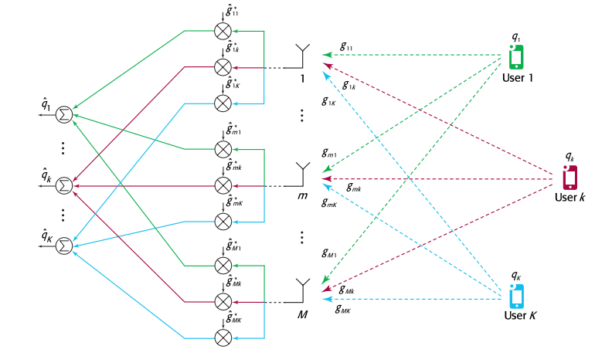Overall, MIMO antennas improve the reliability, performance, and capacity of wireless communication systems by utilizing multiple antennas for simultaneous data transmission and reception.

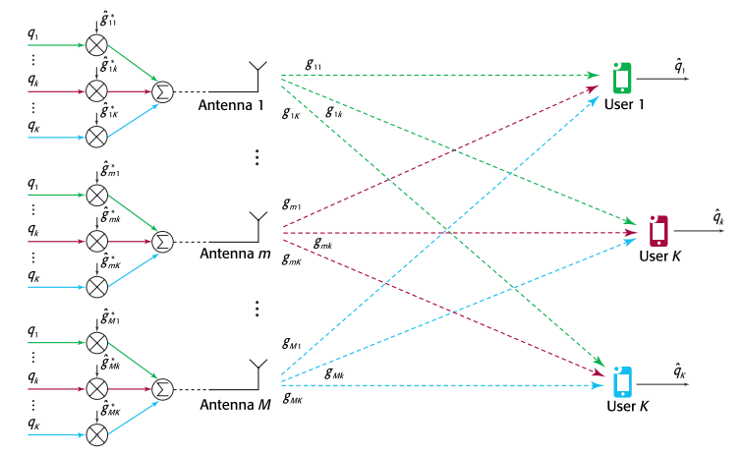

Figure 7 – MIMO as a receiver [[Source](https://doi.org/10.15325/BLTJ.2015.2407793)]

Figure 8 – MIMO as a transmitter [[Source](https://doi.org/10.15325/BLTJ.2015.2407793)]

**2.1.4 Single-user MIMO**

**Single-user MIMO** focuses all the streams of antenna arrays on a single user. Single-user MIMO technology allows data to transfer simultaneously through more than one data streams to one device.  Advantage of SU-MIMO is that there are no interferences and radio channel estimation is easier to achieve. Downside is that it can only serve one device at a time and if tran smission matrix is uncorrelated, MIMO cannot be used.  [16]

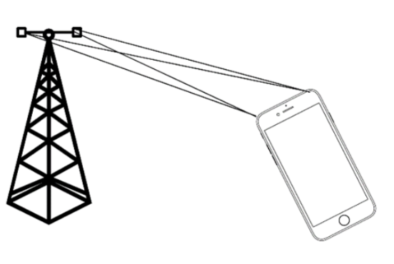

Figure 9 – SU-MIMO [[Source](https://verkotan.com/2023/mimo-mu-mimo-and-massive-mimo-mimo-testing-at-verkotan/)]

**2.1.5 Multi-user MIMO**

**MU-MIMO** is a technology that utilizes more than one antenna to create several connections simultaneously to different devices to improve the network capacity. MU-MIMO, in other words multiple users, multiple input, multiple output, is created to allow multiple users to have access to a base station at the same time. In comparison to standard MIMO, MU-MIMO has multiple data streams to different devices simultaneously.

The advantage of MU-MIMO is that the number of antennas in the devices does not have to be increased. But users’ devices should be able to send channel estimation to the base station and base station needs to find optimal UEs for multiuser MIMO, but it has turned out to be challenging. [16]

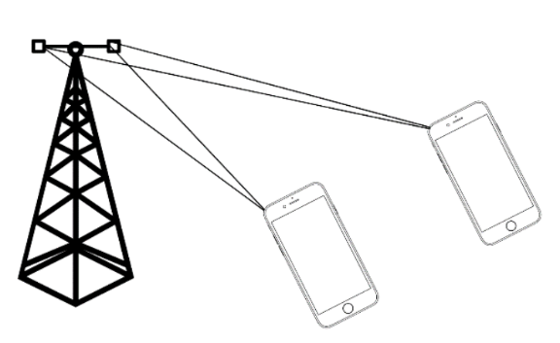

Figure 10 – MU-MIMO [[Source](https://verkotan.com/2023/mimo-mu-mimo-and-massive-mimo-mimo-testing-at-verkotan/)]

**Mathematical Model for Multi-User MIMO System**

Consider K independent users in the multi-user MIMO system. We assume that the BS and each MS are equipped with NB and NM antennas, respectively. Figure shows the uplink channel, known as a multiple access channel (MAC) for K independent users. [17]

Let $x_{u}∈ C^{N_{m}×1}$ and $y_{MAC}∈ C^{N_{B}×1}$ denote the transmit signal from the uth user, $u=1,2,…,k.$ and the received signal at the BS, respectively.

The channel gain between the uth user MS and BS is represented by $H_{u}^{UL}∈ C^{N_{B}×N_{M}}$, $u=1,2,…,k.$

The received signal is expressed as

$y_{MAC}=H_{1}^{UL}x_{1}+H_{2}^{UL}x_{2}+…+H_{k}^{UL}x_{k}+z=\begin{matrix}{[H}_{1}^{UL} & H_{2}^{UL} & … & H_{k}^{UL}\end{matrix}]\left[\begin{matrix}x_{1} \\ x_{2} \\ . \\ x_{k}\end{matrix}\right]+z=H^{UL}\left[\begin{matrix}x_{1} \\ x_{2} \\ . \\ x_{k}\end{matrix}\right]+z$ (1)

where $z∈ C^{N_{B}×1}$ is the additive noise in the receiver.

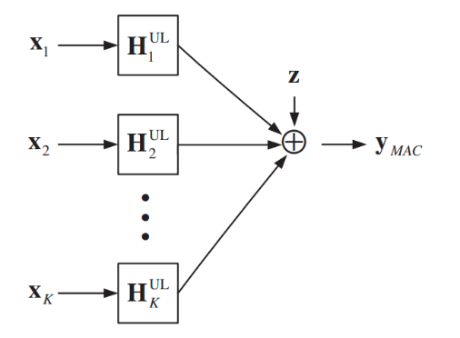

Figure 11 – MU-MIMO uplink channel [[Source](https://onlinelibrary.wiley.com/doi/epdf/10.1002/9780470825631)]

Figure (12) shows the downlink channel, known as a broadcast channel (BC) in which channel $x∈ C^{N_{B}×1}$ is the transmit signal from the BS and $y_{u}∈ C^{N_{M}×1}$ is the received signal at the uth user, $u=1,2,…,k.$ Let $H_{u}^{DL}∈ C^{N_{M}×N_{B}}$ represent the channel gain between BS and the uth user. In MAC, the received signal at the u th user is expressed as

$y_{u}=H_{u}^{DL}x+z_{u}$, $u=1,2,…,k.$ (2)

where $z_{u}∈ C^{N_{M}×1}$ is the additive noise at the u th user. Representing all user signals by a single vector, the overall system can be represented as

$\left[\begin{matrix}y_{1} \\ y_{2} \\ . \\ y_{k}\end{matrix}\right]=\left[\begin{matrix}H_{1}^{DL} \\ H_{2}^{DL} \\ . \\ H_{k}^{DL}\end{matrix}\right]x+\left[\begin{matrix}z_{1} \\ z_{2} \\ . \\ z_{k}\end{matrix}\right]$ (3)

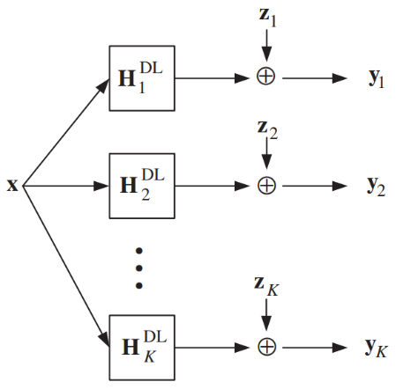

Figure 12 – MU-MIMO downlink channel [[Source](https://onlinelibrary.wiley.com/doi/epdf/10.1002/9780470825631)]

**2.1.6 What is Massive MIMO?**

Massive MIMO or massive multiple-input multiple-output technology is a subset of MU-MIMO technology that involves using a large number of antennas at the transmitter and receiver ends of a wireless communication system or more specifically, at the base stations of cellular networks to improve and increase network performance. [15]

The multiple antennas in a Massive MIMO system work coherently and adaptively to significantly increase throughput, capacity density, and efficiency in a cellular network.

The main concept is to use large antenna arrays at base stations to simultaneously serve many autonomous terminals (figure (13)). The rich and unique propagation signatures of the terminals are exploited with smart processing at the array to achieve superior capacity.

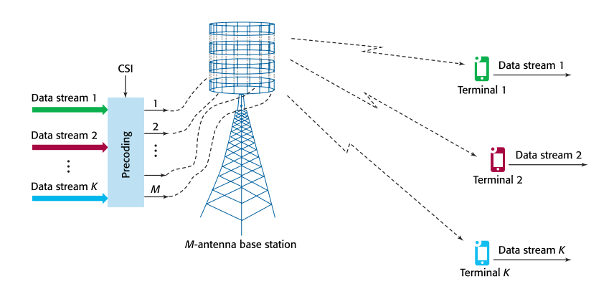

Figure 13 – Massive MIMO Downlink channel [[Source](https://doi.org/10.15325/BLTJ.2015.2407793)]

**Below are the specific benefits and applications of Massive MIMO technology:**

**1. Increases Network Capacity**

Massive MIMO increases the capacity of a particular wireless communication network in two ways. First, it enables the deployment of higher frequencies, such as in the case of Sub-6 5G specification. Second, by employing multi-user MIMO, a cellular base station with Massive MIMO capability can send and receive multiple data streams simultaneously from different users using the same frequency resources.

Note that network capacity is determined by the number or amount of total data a particular network can serve to its end-users, as well as by the maximum number of end-users that can be served based on an expected service level.

**2. Enhances Network Coverage**

Another advantage of Massive MIMO is that it provides high spectral efficiency through the coordination of multiple antennas using simple processing and without intensive power consumption. When used in a 5G cellular network technology, it allows 10 times more spectral and network efficiency compared to fourth-generation networks. Furthermore, when applied in 4G technology, it improves the deep coverage of fourth-generation networks.

Because next-generation cellular network technologies use electromagnetic radiation with higher frequencies or more specifically, frequencies within the upper limits of radio waves and the range of microwaves, the signals they generate travel a short distance. Hence, enhancing network coverage is critical in modern and future cellular technologies.

**3. Complements Beamforming**

Beamforming technology works by focusing a signal toward a specific direction, rather than broadcasting in all directions, thus resulting in more direct communication between a transmitter and a receiver, more stable and reliable connectivity, and faster data transmission. As a signal processing technique and traffic-signaling system, this technology depends on advanced antenna technologies on both access points and end-user devices.

The large number of antennas in a Massive MIMO system enables three-dimensional beamforming in which a single beam of signal-bearing electromagnetic radiation travels through vertical and horizontal directions. The process increases data transmission rates further while reaching people in elevated areas such as buildings and those in moving vehicles.

**4. Enables Next-Gen Technologies**

Massive MIMO is an essential component of 5G technology. For example, in Sub-6 5G specification, it allows the utilization of frequencies within the sub-6 GHz range. Moreover, in mm-Wave 5G specification, this technology increases frequency reach to expand network coverage, optimizes the propagation of signal-bearing electromagnetic radiation, and allows true multi-user wireless communication within a defined area.

However, although it is a key enabling technology for 5G and future cellular network technologies, it has been used for improving and repurposing the capabilities of existing 4G systems, especially LTE Advanced networks. The integration of Massive MIMO in existing 4G networks could improve further network performance. [15]

**2.1.7 Development of MIMO technology (3G to 5G)**

* **In 3G:**

The MIMO technology was first introduced in the mobile networks in the HSPA Evolution (HSPA+) enhancement as part of the 3G network evolution. However, the uptake of MIMO was more noticeable when 4G LTE (Long Term Evolution) networks were launched as they supported MIMO from the first LTE release (3GPP Release 8). [27]

* **In LTE (4G):**

4G networks have seen multiple enhancements to the MIMO configuration to improve data rates and signal quality.

The original 4G LTE networks use MIMO configurations of 4×4 in the downlink and 2×2 in the uplink as per 3GPP Release 8; LTE Advanced and LTE Advanced Pro enhancements use 8×8 MIMO configuration in the downlink and 4×4 in the uplink. [18]

Figure 14 – Antenna configuration for the LTE technologies [[Source](https://commsbrief.com/mimo-in-lte-what-is-multiple-input-multiple-output-in-4g/#:~:text=MIMO%2C%20or%20Multiple%20Input%20Multiple,link%20quality%20and%20data%20rates)]

* **In 5G:**

**With Massive MIMO**, the antenna configuration gets a lot bigger and 64 x 64 is already possible in 5G base stations from key network vendors. However, an antenna configuration of 256 x 256 is also possible.

**2.2 Beamforming**

**2.2.1 What is beamforming?**

Beamforming is a signal processing operation used with antenna arrays to create a *spatial* filter; it filters out signals from all directions except the desired direction(s). Beamforming can be used to increase SNR of desired signals, null out interferers, shape beam patterns, or even transmit/receive multiple data streams at the same time and frequency.

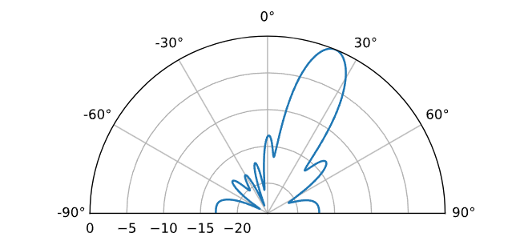As part of beamforming, we use weights (a.k.a. coefficients) applied to each element of an array, either digitally or in analogy circuitry. We manipulate the weights to form the beam(s) of the array, hence the name beamforming! We can steer these beams (and nulls) extremely fast; much faster than mechanically gimballed antennas, which can be thought of as an alternative to phased arrays. [4]

Figure 15 – Beamforming Example [[Source](https://pysdr.org/content/doa.html)]

**2.2.2 Beamforming in MIMO systems?**

*Beamforming* is the most commonly used method by a new generation of smart antennas. In this method, an array of antennas is used to “steer” or transmit radio signals in a specific direction, rather than simply broadcasting energy/signals in all directions inside the sector. In this method, multiple smaller antennas control the direction of the combined transmitted signal by appropriately weighing the magnitude and phase of each of the smaller antenna signals. In this technique, the phase and amplitude of the transmitted signal of each component antenna are adjusted as needed, resulting in a constructive or destructive effect, concentrating the total transmitted signal into a targeted beam. [21]

The method by which beamforming is achieved is growing increasingly more sophisticated, partly thanks to contemporary **Massive MIMO Antennas**. MIMO technology lets radio signals to be sent and received using several antennas. Massive MIMO antennas have many more component antennas that allow them to transmit radio signals more efficiently. This allows for very high data rates.

Figure 16 – Beamforming antenna array Vs Sectored antenna array [[Source](https://verkotan.com/2021/beamforming-antennas-how-they-work-and-are-tested/)]

Beamforming in MIMO systems uses multiple antenna elements to control the direction of a signal. By changing the phase of the individual signals in an antenna array the beam can be formed at the desired angle. The signal can then be directed in the desired direction $θ$ like depicted in figure (17).

Figure 17 – Beamforming array [[Source](https://verkotan.com/2021/beamforming-antennas-how-they-work-and-are-tested/)]

**2.2.3 Benefits of beamforming**

* **Overcoming challenges in 5G networks**

As 5G networks continue their global rollout, enabling smartphones, connected devices, and wide-area networking applications, beamforming emerges as a critical core technology. The high-frequency millimeter wave spectrum used in 5G communications is susceptible to disruptions from obstacles like walls and other barriers, posing challenges for reliable connectivity. Beamforming plays a crucial role in mitigating these challenges by allowing transmitters to focus their signals in specific directions towards mobile devices, vehicles, or Internet of Things (IoT) devices. This directional transmission not only enhances signal strength but also improves the overall reliability of 5G connections.

* **Enhanced performance, Efficiency and capacity**

Moreover, beamforming will be a key enabler for Massive MIMO technology in 5G networks, which, in conjunction with beamforming, can direct beams both horizontally and vertically towards user devices. This precise beam steering capability not only maximizes throughput but also optimizes spectral efficiency, leading to improved network performance and capacity.

* **Enhanced reliability, speed and latency**

By precisely shaping and directing the radio frequency (RF) signals, beamforming overcomes the inherent limitations of mm-Wave frequencies, ensuring reliable, high-speed, and low-latency connectivity for 5G applications. As a pivotal technology, beamforming is poised to play a vital role in unlocking the full potential of 5G networks, enabling seamless and efficient wireless communications for a vast array of devices and use case. [2]

**Overall advantages and Challenges:**

**Advantages:** Beamforming improves signal quality, extends coverage range, mitigates interference, and enhances spectral efficiency, leading to better overall performance.

**Challenges:** Beamforming systems require accurate channel estimation, synchronization, and coordination, while also facing limitations in terms of hardware complexity and power consumption.

**2.2.4 Beamforming techniques**

Beamforming approaches can be broken down into three categories, namely: conventional, adaptive, and blind. [4]

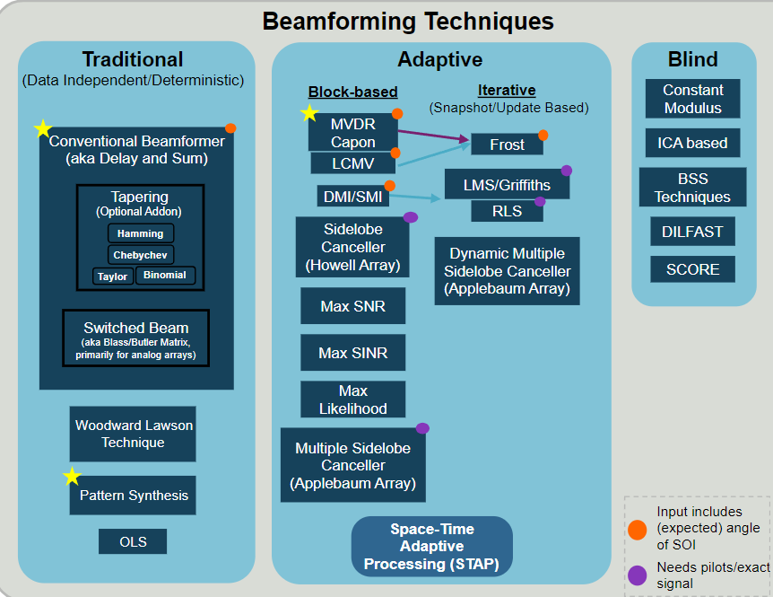

Figure 18 – Beamforming Techniques [[Source](https://pysdr.org/content/doa.html)]

**Conventional beamforming** is most useful when you already know the direction of arrival of the signal of interest, and the beamforming process involves choosing weights to maximize the array gain in that direction. This can be used on both the receive or transmit side of a communication system.

**Adaptive beamforming**, on the other hand, typically involves adjusting the weights based on the beamformer’s input, to optimize some criteria (e.g., nulling out an interferer, having multiple main beams, etc.). Due to the closed loop and adaptive nature, adaptive beamforming is typically just used on the receive side, so the “beamformer’s input” is simply your received signal, and adaptive beamforming involves adjusting the weights based on the statistics of that received data. [4]

**Types of beamforming**

**1- Analog beamforming**

* Phase shifters or variable attenuators are used at each antenna element to adjust the phase and amplitude of signals.
* Signals are combined into a single beam.
* Lower power consumption but limited flexibility.
* Difficult to support multiple beams or dynamic adaptation.
* 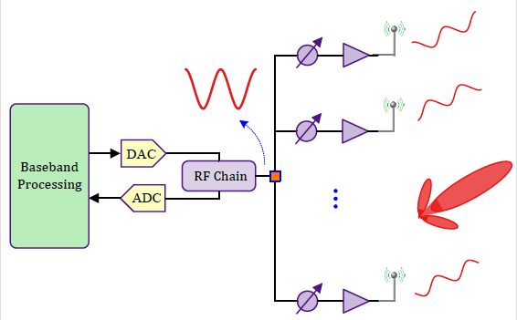Uses single RF chain.

Figure 19 – Analog Beamforming Receiver [[Source](https://wirelesspi.com/what-is-the-difference-between-analog-digital-and-hybrid-beamforming/)]

**2- Digital beamforming**

* Signals from all antenna elements are processed digitally using algorithms to form and steer beams.
* Can form multiple beams simultaneously.
* Supports dynamic beam steering and adaptation.
* Requires high computational power and energy due to the need for multiple ADCs/DACs.
* 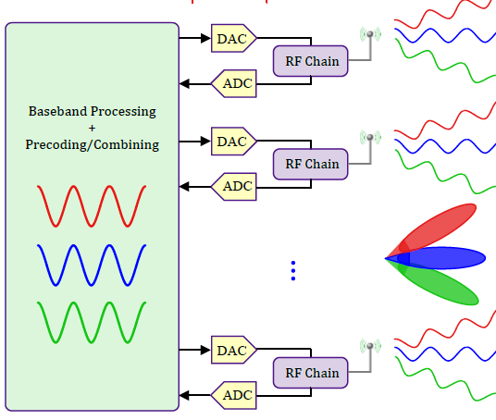Uses multiple RF chains.

Figure 20 – Digital Beamforming Receiver [[Source](https://verkotan.com/2023/mimo-mu-mimo-and-massive-mimo-mimo-testing-at-verkotan/)]

**3- Hybrid beamforming**

* Hybrid beamforming combines analog and digital beamforming, striking a balance between flexibility and cost.
* A smaller number of digital signal chains are used, with analog phase shifters applied for additional processing.
* The signal is split into multiple analog beams and then processed digitally.
* Reduces the cost and power consumption of fully digital systems. [10]

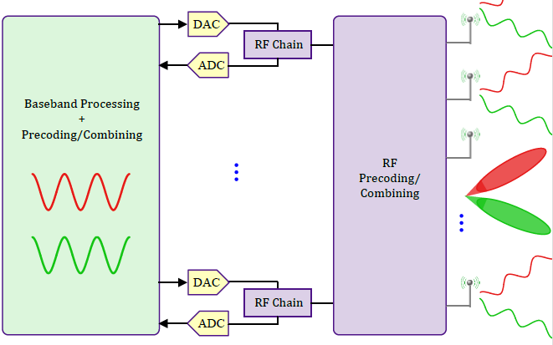

Figure 21 – Hybrid Beamforming Receiver [[Source](https://verkotan.com/2023/mimo-mu-mimo-and-massive-mimo-mimo-testing-at-verkotan/)]

**2.3 Digital beamforming**

In digital beamforming, each antenna has its own RF chain, and the signal processing is done in the digital domain. This allows more control over the beam patterns and supports multiple beams and users.

Key Advantages of Digital Beamforming:

* Increased Control: Digital beamforming allows for precise control over beam patterns. The digital processing can adaptively change the beam shape and direction based on real-time conditions or user locations.
* Multiple Beams: Digital beamforming can create multiple independent beams simultaneously. This capability supports MIMO (Multiple Input Multiple Output), enabling the base station to serve multiple users at different angles with distinct beams.
* Flexibility: The ability to adjust both phase and amplitude means that digital beamforming can optimize performance for different environments and user requirements, making it much more versatile than analog beamforming.

Digital beamforming represents a significant advancement over analog beamforming by enabling enhanced flexibility and capacity to manage complex communication scenarios, particularly in modern wireless networks like 5G.

**2.3.1 Phased arrays:**

A phased array is an electronically scanned array, a computer-controlled array of antennas which creates a beam of radio waves that can be electronically steered to point in different directions without moving the antennas. The general theory of an electromagnetic phased array also finds applications in ultrasonic and medical imaging application (phased array ultrasonics) and in optics optical phased array.

In a simple antenna array, the radio frequency current from the transmitter is fed to multiple individual antenna elements with the proper phase relationship so that the radio waves from the separate elements combine (superpose) to form beams, to increase power radiated in desired directions and suppress radiation in undesired directions. [3]

Phased arrays are introduced as versatile antenna systems capable of shaping and scanning radiation patterns by adjusting the spacing and excitation of multiple elements. Unlike traditional mechanically steered aperture antennas, phased arrays use electronic phase adjustments to achieve rapid and precise beam scanning, eliminating the need for mechanical movement. This approach also supports multiple simultaneous beams and conformal geometries, making phased arrays suitable for applications like radar.

To excite an antenna, we apply alternating current on its terminals as in figure (22).

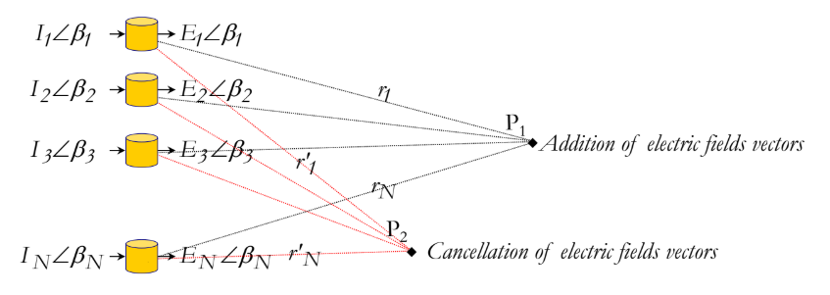To steer a beam in a certain direction using phased array we excite the antennas with the same current amplitude but different phase $β$. By changing the phase shifts between the elements, we change the positions of the constructive (Addition of electric fields vectors) and distractive (cancellation of electric fields vectors) interferences which changes the directions of beam maxima and minima. Phased arrays increases the overall directivity (narrower beam) and gain.

Figure 22 – Antenna array model [Stutzman, W. L., & Thiele, G. A. (2013). Antenna Theory and Design. Wiley]

**Types of phased arrays:**

* **Uniform phased array:**

Constant current amplitude across all the elements of the array, but different phase.

* **Non uniform phased array:**

Different current amplitude as well as different phase across all the elements on the array.

The non uniform phase array has higher capability for cancelling side lobes (gain tapering) and better performance because it’s enabling more precise beamforming and focusing of the energy in the desired directions.

**The factors affecting phased arrays:**

**1- Number of elements:**

As the number of elements increase the gain, directivity and control increase but this also increases cost, power consumption and complexity of the signal processing.

**2- Element spacing:**

As the spacing increase the beam becomes more sharper but grading lobes appear in the beam pattern.

**3- Array geometry**

The way that we construct the array and position the antennas. The common geometry patterns are linear, planar, and circular arrays.

Starting with one isotropic antenna that radiates a sinusoidal wave in all directions, the wave front of this radiation is shown in figure (23).

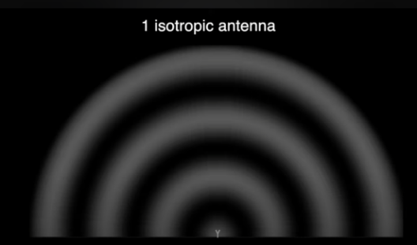

Figure 23 – Single isotropic antenna radiation pattern [[Source](https://www.youtube.com/watch?v=9WxWun0E-PM&ab_channel=MATLAB)]

Two identical isotropic antennas with spacing of $d=\frac{λ}{2}$

Figure 24 – Two isotropic antennas radiation pattern [[Source](https://www.youtube.com/watch?v=9WxWun0E-PM&ab_channel=MATLAB)]

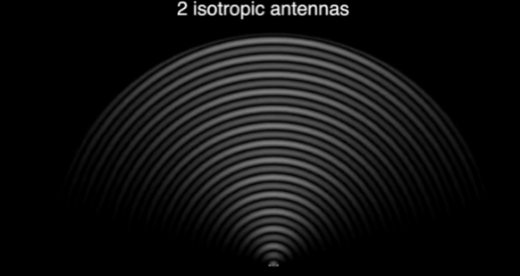

Figure 25 – Two isotropic antennas radiation pattern (zoomed out) [[Source](https://www.youtube.com/watch?v=9WxWun0E-PM&ab_channel=MATLAB)]

In figure (24) and (25), we have destructive interference in the right and left sides and constructive interference on the top side resulting in more directive output beam than the case with single antenna.

**For sharper beam**

1- Increase the distance between two antennas (ex, spacing = $λ$) leads to sharper beam but grating lobes appears as we see in figure (26). Grating lobes are an unwanted lobe that have gain comparable with the gain of the main lobe (power loss).

2-Increase the number of antennas with the same initial spacing of $\frac{λ}{2}$ which increases the directivity as we see in figure (27). Side lobes appear but their power is much less than that of main lobe.

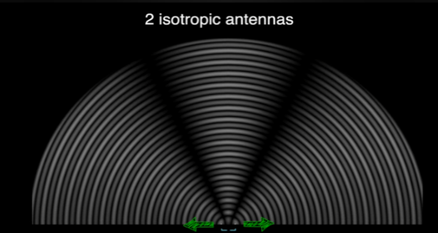

Figure 26 – Two isotropic antennas with spacing $λ$ radiation pattern [[Source](https://www.youtube.com/watch?v=9WxWun0E-PM&ab_channel=MATLAB)]

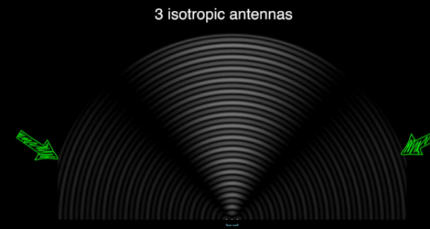

Figure 27 – Three isotropic antennas radiation pattern [[Source](https://www.youtube.com/watch?v=9WxWun0E-PM&ab_channel=MATLAB)]

**For steering**

We change the phase of one of the two antennas (ex, phase shift = 0.5 lambda) which produces the result in figure (28).

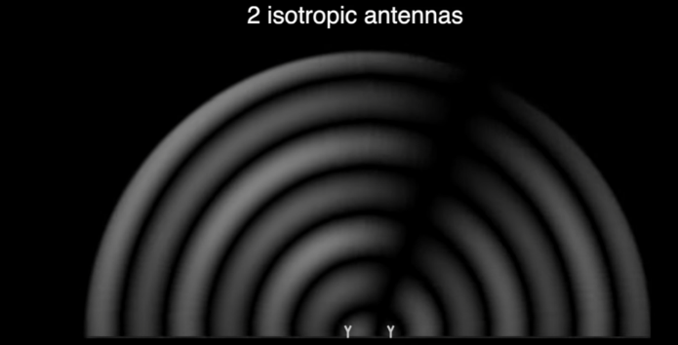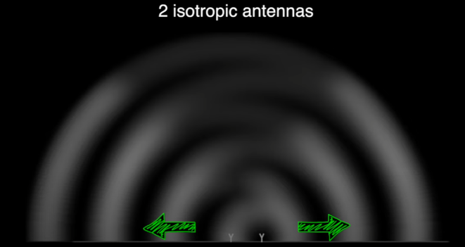

Figure 28 – Two isotropic antennas with phase shift radiation pattern [[Source](https://www.youtube.com/watch?v=9WxWun0E-PM&ab_channel=MATLAB)]

By comparing with the previous results in figures (24) and (25) with figure (28), we find that applying a phase shift caused a rotation in the main beam.

**8-Element array**

For an 8-Element antenna array, we get more clear results as depicted in figure (29). Increasing the number of elements results in a sharper beam.

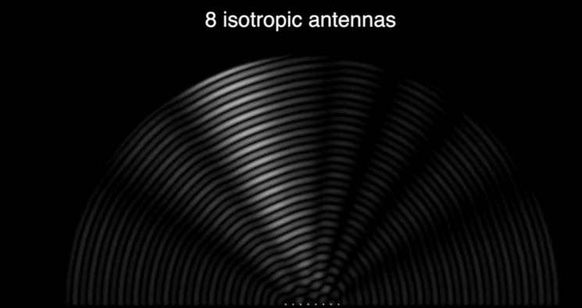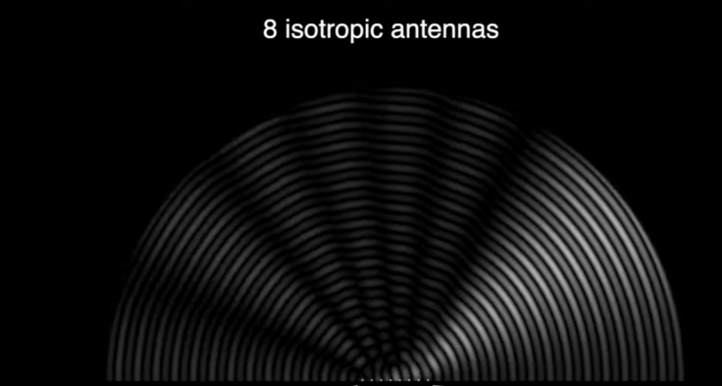

Figure 29 – Eight isotropic antennas with beam steering [[Source](https://www.youtube.com/watch?v=9WxWun0E-PM&ab_channel=MATLAB)]

**2.3.2 Steering Vector**

Consider a 1D uniformly spaced array:

In this example, the signal comes from the right side, so it hits the right element first as shown in Figure (30).

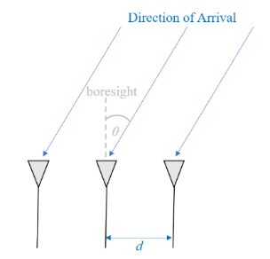

Figure 30 – ULA [[Source](https://pysdr.org/content/doa.html)]

Let’s calculate the delay between when the signal hits that first element and when it reaches the next element. We can do this by forming the following trig problem.

In figure (31) the segment highlighted in red represents the distance the signal has to travel after it has reached the first element, before it hits the next one.

$adjacent=dsin(θ)$ (4)

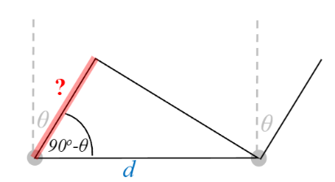

Figure 31 – Delay calculation [[Source](https://pysdr.org/content/doa.html)]

Now to connect this trig and speed of light math to the signal processing world. Let’s denote our transmit signal at baseband $x(t)$ and it’s being transmitting at some carrier, $f_{c}$  , so the transmit signal is

$x\left(t\right)e^{j2πf_{c}t}$ (5)

We’ll use $d_{m}$  to refer to antenna spacing in meters. Let’s say this signal hits the first element at time $t=0$ , which means it hits the next element after

$\frac{d_{m}sin⁡(θ)}{c}$ (6)

This means the 2nd element receives:

$x\left(t-∆t\right)e^{j2πf_{c}(t-∆t)}$ (7)

where $∆t=\frac{d_{m}sin\left(θ\right)}{c}$ (8)

When the receiver does the **down conversion** process to receive the signal, it’s essentially multiplying it by the carrier but in the reverse direction, so after down conversion the receiver sees:

$x\left(t-∆t\right)e^{j2πf_{c}(t-∆t)}e^{-j2πf_{c}t}=x\left(t-∆t\right)e^{-j2πf_{c}∆t}$ (9)

Now to simplify this even further; when we sample a signal it can be modeled by substituting $t$  for $nT$  where $T$  is sample period and $n$  is just 0, 1, 2, 3…

Substituting this in we get

$x\left(nT-∆t\right)e^{-j2πf_{c}∆t}$ (10)

Well, $nT$  is so much greater than $∆t$  that we can get rid of the first $∆t$  term so we are left with

$x\left(nT\right)e^{-j2πf_{c}∆t}$ (11)

If the sample rate ever gets fast enough to approach the speed of light over a tiny distance, we can revisit this, but our sample rate only needs to be double the signal of interest’s bandwidth.

The last equation can be represented in discrete terms as the following, let’s plug back in $∆t$ :

$x\left[n\right]e^{-j2πf_{c}∆t}=x\left[n\right]e^{-j2πf_{c}(\frac{d_{m}\sin\left(θ\right)}{c}) }$ (12)

$λ=\frac{c}{f_{c}}$ (13)

Plugging this in we get:

$x\left[n\right]e^{-j2π(\frac{d_{m}\sin\left(θ\right)}{λ}) }$ (14)

In beamforming, we represent $d$ , the distance between adjacent elements, as a fraction of wavelength (instead of meters). The most common value chosen for $d$  during the array design process is to use half the wavelength.

$d$ (without the subscript $m$ ) represents normalized distance

$d=\frac{d_{m}}{λ}$ (15)

We can simplify (14) to:

$x\left[n\right]e^{-j2πdsin(θ) }$ (16)

The above equation is specific to adjacent elements, for the signal received by the $k$ ’th element we just need to multiply $d$  times $k$ :

$x\left[n\right]e^{-j2πdksin(θ) }$ (17)

The matrix denoted by $s$ is the called the “steering vector”

$s=\left[\begin{matrix}1 \\ e^{-j2πd(1)sin(θ) } \\ e^{-j2πd(2)sin(θ) } \\ : \\ e^{-j2πd(N_{r}-1)sin(θ) }\end{matrix}\right]$ (18)

To get the received signals at the different $N_{r}$ antenna elements we multiply the transmitted signal $x[n]$ by the steering vector $s$

$X=s ×x[n]$ (19)

$x[n]$: The transmitted signal vector of size $1×N$ (N is the number of samples per signal).

$s$: The steering vector of size $N_{r}×1$.

$X$: The received signals at the $N_{r}$ elements ($N_{r}×N$). [4]

**2.3.3 Delay and sum Beamforming**

On the top of figure (32), we have a scenario where a desired signal is received and the appropriate time delays (*t₁, t₂*) are applied such that the signals constructively interfere and the array produces a high response. On the bottom, we have an undesired signal and no time delays are applied, there is no constructive interference and the array does not have a high response to this signal. [5]

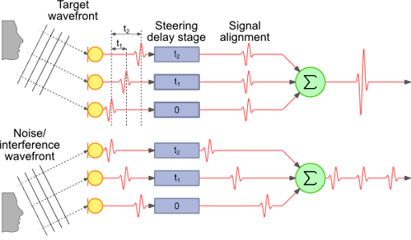

Figure 32 – Delay and sum beamforming [[Source](https://medium.com/@itberrios6/introduction-to-beamforming-part-1-92767408f483)]

The Delay-and-Sum Beamformer applies a time delay to the incoming signal from each element and sums the output together. If we get the time delays correct, we will have a single high output signal. We can then use the time delays that produced this signal to determine the angle of its arrival.

Our weights vector $w$  needs to be a 1D array for a uniform linear array. With delay and sum beamforming we leave the magnitude of the weights at 1, and adjust the phases so that the signal constructively adds up in the direction of our desired signal, which we will refer to as $θ$ . In delay and sum it turns out that it has the exact same math we did above in the steering vector so our weights are our steering vector. [4]

$w=e^{-j2πdksin(θ) }$ (20)

$Y=w^{H}.X$ (21)

$w$: weights vector of size $N_{r}×1$

$Y$: The beamformed signal ($1×N$).

**DOA**

But how do we know the angle of interest theta? We must start by performing DOA, which involves scanning through (sampling) all directions of arrival from -π to +π (-180 to +180 degrees). At each direction we calculate the weights using a beamformer. Applying the weights to our signal will give us a 1D array of samples, as if we received it with 1 directional antenna. We can then calculate the power in the signal by taking the variance, and repeat for every angle in our scan. We plot the results and look at it with our human eyes, but what most RF DSP does is find the angle of maximum power (with a peak-finding algorithm) and call it the **DOA estimate**. [4]

**2.2.4 MVDR/Capon Beamformer**

A beamformer that is slightly more complicated than the conventional/delay-and-sum technique, but tends to perform much better is called the Minimum Variance Distortion Less Response (MVDR) or Capon Beamformer. We know that variance of a signal corresponds to how much power is in the signal. The idea behind MVDR is to keep the signal at the angle of interest at a fixed gain of 1 (0 dB), while minimizing the total variance/power of the resulting beamformed signal. If our signal of interest is kept fixed then minimizing the total power means minimizing interferers and noise as much as possible. It is often referred to as a “statistically optimal” beamformer.

Let’s recall (21), we process the received signal **X** with a matrix multiplication.

We can impose a constraint on ***w*** such that the resulting Array Output ***Y*** is exactly equal to the original signal $f$ (previously x[n]).

$Y=f$ (22)

Since the recovered signal is exactly equal to the original (*i.e. no distortion*) this is called the **Distortion less Response**. Now, if ***w***is actually equal to the true signal steering vector $s(Ɵ_{s})$ then their inner product will be equal to 1. We can reformulate this constraint with the following expression.

$s^{H}.w=1 or w^{H}.s=1$ (23)

This is our **Distortion less Constraint** for our Beamformer ***w***. This essentially does two things.

First, it forces our Beamformer to be *steered* in the direction of the true signal by forcing the energy of the Beamformer response to be high in this direction.

Second, it forces the energy of the response to be low in all other directions, this is sometimes called ***steering a null*** in all other directions. **The drawback of this, is that our Beamformer is intended to work for a single signal, since we are only considering a single signal in our model**.

Now let’s turn our attention to the output of this Beamformer so that we can construct the objective function.

**Distortion less Response of a Noisy Signal**

Let’s incorporate the Distortion less Response into the General Beamformer and inspect its response with a noisy signal

$X_{n} = X + n$ (24)

where **n** is zero mean Additive Gaussian White Noise (AWGN).

 The output of the beamformer using a weight vector $w$  is given by:

$$y=w^{H}.X_{n}$$

$$=w^{H}.(X + n)$$

$$=w^{H}.X + w^{H}.n$$

$$=f+w^{H}.n$$

$Y=f+y_{n}$ (25)

We have the original signal $x[n]$ plus the processed noise term $y_{n}$ , this extra noise term will cause errors in our estimates. We need to find a way to minimize this noise in order to retain an accurate estimate. The power of the noise is characterized by its variance, so a proper way to state our goal would be to minimize the variance of the noise. But there’s a problem here, we don’t get our signal and noise separately, we get them together in a package deal. So, we really need to minimize the variance of the total response ***Y***(*i.e. the term we have access to*) so that our estimate is accurate. Now let’s piece this together, our response is assumed to be distortion less without the presence of noise, so we will minimize the variance of the distortion less response.

Since we are minimizing the variance of the Distortion less response, let’s see what this variance term actually looks like. Below, we simplify the variance of the Distortion less Response $Y$ .

$$var\left(Y\right)=E[{\left|Y\right|}^{2}]+E{[Y]}^{2}$$

$$=E[{\left|Y\right|}^{2}]+E{[f+y_{n}]}^{2}$$

$$=E[{\left|Y\right|}^{2}]+{\left(E\left[f\right]+E\left[y_{n}\right]\right)}^{2}$$

$$=E[{\left|Y\right|}^{2}]+0$$

$$=E(|{\left.​w^{H}.X_{n}\right|}^{2})$$

$$=E[\left(w^{H}.X_{n}\right).{\left(w^{H}.X_{n}\right)}^{H}]$$

$$=E[w^{H}.X_{n}.w.X_{n}^{H}]$$

$$=w^{H}.E\left[X_{n}.X_{n}^{H}\right].w$$

$var\left(Y\right)=w^{H}.R.w$ (26)

We have used the fact that *f* and $y_{n}$  are zero mean.

$R$ is an $N_{r}×N_{r}$ sample correlation matrix.

$w$ is the Beamformer weighting that will produce the recovered signal.

This expression is our objective function that we will minimize subject to the Distortion less Constraint.

The Optimization Problem:

Minimize $w^{H}.R.w$ (minimize the total power of the signal)

Subject to: $w^{H}.s=1$ (no distortion and the received signal is exactly like the original one)

**Lagrangian Method -** Introduce a Lagrange multiplier λ and form the Lagrangian:

$L\left(w,λ\right)=w^{H}.R.w-λ.\left(w^{H}.s-1\right)$ (27)

**Solving the Optimization** - Differentiating the Lagrangian with respect to the $w^{H}$  and setting the derivative to zero, we obtain:

$$\frac{∂L}{∂w^{*}}=2R.w-λ.s=0$$

$$w= λ.s.R^{-1}$$

$w=\frac{λ.s}{R}$ (28)

To solve for $λ$ , apply the constraint $w^{H}.s=1$

$$\left(λ.s^{H}.R^{-1}\right).s=1$$

$λ=\frac{1}{s^{H}.R^{-1}.s}$ (29)

substituting (29) in (28) we get

$w_{mvdr}=\frac{R^{-1}.s}{s^{H}.R^{-1}.s}$ (30)

If we already know the direction of the signal of interest, and that direction does not change, we only have to calculate the weights once and simply use them to receive our signal of interest. Although even if the direction doesn’t change, we benefit from recalculating these weights periodically, to account for changes in the interference/noise, which is why these non-conventional digital beamformers are referred to as “adaptive” beamformers; they use the received signal information to calculate the weights.

We can perform beamforming using MVDR by calculating these weights and applying them to the, just like we did in the conventional method, the only difference is how the weights are calculated. [5]

**DOA**

We simply repeat the MVDR calculation while scanning through all angles of interest. At each angle we calculate the MVDR weights, then apply them to the received signal, then calculate the power in that signal. The angle that gives us the highest power is our DOA estimate.

**2.3.5 LCMV Beamformer**

Linearly Constrained Minimum Variance (LCMV) beamformer is used if we have more than one SOI (signal of interest). It is a generalization of MVDR, where we specify the desired response for multiple directions. [26]

LCMV Beamformer determines the optimal weight vector that minimizes the output power while satisfying one or more linear equality constraints. The optimization problem for this beamformer is given by,

$$\min{w^{H}Rw} subject to k linear constraints C^{H}w=f$$

The constraint matrix $C$ contains $k$ steering vectors and $f$ is the gain vector corresponding to each steering vector contained in the matrix $C$. The solution to this optimization problem comes out to be,

$w_{lcmv}=R^{-1}C{\left[C^{H}R^{-1}C\right]}^{-1}f$ (31)

$R$ is an $N×N$ sample correlation matrix.

$C$ is a $N_{r}×n$ matrix comprising of steering vectors at the AOAs of $(n)$ SOIs and interferers.

$f$ the desired response vector. The vector  for a particular row takes the value of 0 when the corresponding steering vector is to be nulled, and takes a value of 1 when we want a beam pointed at it. For example, if we have two sources of interest and two sources of interference, we can set $f$  = [1,1,0,0].

The LCMV beamformer is a powerful tool that can be used to suppress interference and noise from multiple directions while simultaneously enhancing the signal of interest from multiple directions.

The catch is that the total number of nulls and beams (size of the vector $f$) you can form simultaneously is limited by the size of the array (the number of elements).

Furthermore, you need to craft the steering vector for each of the SOIs (signals of interest) and interferers, which isn’t always readily available in practical applications.

When estimates are used instead, the performance of the LCMV beamformer can degrade. It is for this reason that we prefer to steer nulls using the spatial covariance matrix $R$  (based on statistics of the received signal), instead of “hardcoding” nulls by estimating the AoA of the interferer (which could have error) and crafting the steering vector in that direction, with a 0 added to $f$ . [4]

**2.3.6 Subspace Techniques**

We will now talk about a different kind of beamformers, the “sub-space” methods. These involve dividing the signal subspace and noise subspace, which means we must estimate how many signals are being received by the array for good results.

**2.3.6.1 MUSIC Algorithm**

Multiple Signal Classification (MUSIC) is a high-resolution algorithm for estimating the Directions of Arrival (DOAs). The MUSIC algorithm is based on the decomposition of the covariance matrix of signals received from antenna array.

Eigen decomposition is an operation that breaks a matrix down into its eigenvalues and eigenvectors to help you better understand its properties.

After calculating the eigenvectors of the covariance matrix, we split the eigenvectors into two groups: signal sub-space and noise-subspace, then project steering vectors into the noise sub-space and steer for nulls. [13]

MUSIC algorithm uses the eigenvectors decomposition and eigenvalues of the covariance matrix of the antenna array for estimating directions-of-arrival of sources based on the properties of the signal and noise subspaces.

For this, the initial hypothesis is that the covariance matrix 𝑅 is not singular. This assumption physically means that sources are totally uncorrelated between them. MUSIC algorithm assumes that signal and noise subspaces are orthogonal. The signal subspace 𝐸 consists of phase shift vectors between antennas depending on the angle of arrival. All orthogonal vectors to $E_{s}$ constitute a subspace $E_{N}$ called noise subspace.

MUSIC algorithm being based on the properties of signal and noise subspaces, vectors derived from $E_{s}$ generate a signal subspace collinear with steering vectors of sources $a(θ_{k})$ and vectors derived from $E_{N}$ generate a noise subspace **orthogonal** to the steering vectors of these sources.

It follows that:

$E_{N}^{H}.a\left(θ_{k}\right)=0 for k =1, 2, …,K$ (32)

For determining various directions-of-arrival, it is necessary to diagonalize the covariance matrix of the data, identify the signal and noise space, and project onto the noise space. The principle is to project all possible directional vectors (averaging over several vectors) on the noise subspace and retain only those minimizing this projection, resulting in the following discriminant function:

$d^{2}=a{\left(θ\right)}^{H}E_{N}E_{N}^{H}a\left(θ\right)=0$ (33)

($E_{N}=[e_{1}, e_{2}, …,e_{M-K}]$) (34)

whose zeros are the directions-of-arrival.

$C=E_{N}.E_{N}^{H}$ is the projection matrix and $a{\left(θ\right)}^{H}E_{N}E_{N}^{H}a\left(θ\right)$ is the projection of the vector $a\left(θ\right)$ on the noise subspace (the projection is zero at the true DOA).

Estimating directions-of-arrival of signals is equivalent to look for maximum values of the MUSIC pseudo-spectrum $P(θ)$:

$P_{MUSIC}\left(θ\right)=\frac{1}{A\left(θ\right)E_{n}E_{n}^{H}A\left(θ\right)}$ (35)

The MUSIC equation that will be used in **modelling** to determine the angle of arrival is the following: [4]

$θ=argmax(\frac{1}{s^{H}V_{n}V_{n}^{H}s})$ (36)

Where:

$V_{n}$ is that list of noise sub-space eigenvectors (a 2D matrix).

$s$ is the steering vector

argmax operator finds the angle $θ$ at which the MUSIC spectrum is maximized.

$V_{n}$ is found by first calculating the eigenvectors of the covariance matrix $R$, and then splitting up the vectors based on how many signals we think the array is receiving. The number of signals must be between $1$ and $N_{r} - 1$ . If you are designing an array, when you are choosing the number of elements you must have one more than the number of anticipated signals.

Note: $V_{n}$ does not depend on the steering vector $s$ . [4]

**2.3.6.2 ESPRIT Algorithm**

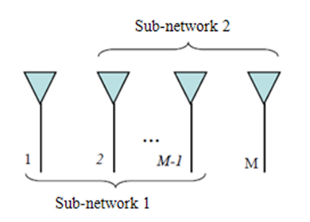ESPRIT (Estimation of Signal Parameters via Rotational Invariance Techniques) was developed by Roy and Kailath in 1989. It is based on the rotational invariance property of the signal space to make a direct estimation of the DOA and obtain the angles of arrival without the calculation of a pseudo-spectrum on the extent of space, nor even the search for roots of a polynomial. This method exploits the property of translational invariance of the antenna array by decomposing the main network into two sub-networks of identical antennas which one can be obtained by a translation of the other as depicted in figure (33). [13]

Figure 33 – Decomposing the network into two sub-networks

The main advantage of this method is that it avoids the heavy research of maxima of a pseudo-spectrum or a cost function (therefore a gain calculation) and the simplicity of its implementation. In addition, this technique is less sensitive to noise than MUSIC. By designating $x_{1}(t)$ and $x_{2}(t)$ as observation vectors at the outputs of sub-networks 1 and 2, the received signal vector in baseband of the complete network is written as following:

$x\left(t\right)=\left[\begin{matrix}x_{1}\left(t\right) \\ x_{2}\left(2\right)\end{matrix}\right]=\left[\begin{matrix}A \\ A.Φ\end{matrix}\right].S_{k}\left(t\right)+n\left(t\right)$ (37)

$Φ=diag[e^{j\frac{2π}{λ} dsinθ_{1}}, e^{j\frac{2π}{λ} dsinθ_{2}}, …,e^{j\frac{2π}{λ} dsinθ_{k}}]$ (38)

This relation will allow estimation of the angles of arrival without knowing the expression of the matrix A of sources vectors. It so allows the use of the ESPRIT algorithm to antennas of badly known or unknown geometry.

The correlation matrix of the complete network is given by:

$R_{xx}=\left[\begin{matrix}A \\ A.Φ\end{matrix}\right]R_{ss}\left[\begin{matrix}A^{H} \\ A^{H}.Φ^{H}\end{matrix}\right]+σ^{2}I$ (39)

Where $A=\left[a\left(θ_{1}\right), a\left(θ_{2}\right), … , a(θ_{k})\right]$ is a $MxK$ matrix of the source vectors defined in a sub-network and $R_{ss}$ is the spatial matrix of sources.

The matrix $R_{xx}$ being Hermitian, its eigenvalues are real: ($λ_{1}≥λ_{2}≥…≥λ_{k}≥λ_{k+1}=σ^{2}$).

The largest $K$ eigenvalues correspond to the space signal generated by the K sources. The signal subspace $E_{S}$ is a $M×K$ matrix composed of $K$ eigenvectors associated with the signal subspace. The signal subspace $E_{S}$ of the whole network can be decomposed into two subspaces $E_{1}$ and $E_{2}$ which are the $(M-1)×K$ matrices whose columns are composed of K eigenvectors corresponding to eigenvalues of the covariance matrices of the sub-networks 1 and 2.

These two matrices $E_{1}$ and $E_{2}$ are related by the following relation of invertible linear transformation:

$E_{s}=\left[\begin{matrix}E_{1} \\ E_{2}\end{matrix}\right]=\left[\begin{matrix}AT \\ A.ΦT\end{matrix}\right]$ (40)

$T=R_{11}^{-1}.R_{21}$ (41)

$R_{11}=\frac{1}{N}X_{1}X_{1}^{H}$ (42)

$R_{21}=\frac{1}{N}X_{2}X_{1}^{H}$ (43)

$R_{11}$ and $R_{21}$ are the covariance matrices between the two sub-networks of antennas.

$E_{2}=ATT^{-1}ΦT=E_{1}Ψ$ (44)

Where the rotation matrix is a $K×K$ matrix

$Ψ=E_{2}/E_{1}$ (45)

The eigenvalues of $Φ$ and $Ψ$ are common and are expressed by $λ_{i}=e^{jkdsinθ_{i}}$ with $k=1, 2, …,K$

The angles of arrival are given by

$λ_{i}=|λ_{i}|e^{jarg(λ_{i})}$ (46)

$θ_{i}=\sin^{-1}{(\frac{arg(λ_{i})}{kd})} i= 1, 2,…,K$ (47)

$K=\frac{2π}{λ}$ is the wave number

d is the distance between antennas in meters so

$Kd=\frac{2πd}{λ}$ (48)

In practice to determine directions of arrival, it is necessary to:

* Achieve the decomposition in singular value of the data covariance matrix where is the number of observations.
* Estimate the dimension of the signal subspace (40).
* Separate the eigenvectors corresponding to the signal subspace and form the matrices of sub-networks $E_{1}$ and $E_{2}$.
* Estimate the rotation operator $Ψ$ (45).
* Calculate the eigenvalues $λ_{1}, λ_{2},…,λ_{k}$ of the matrix $Ψ$ (46).
* Finally, calculate the AOAs (47).

**Ch 3: MATLAB Implementation & Simulation**

For the modelling of the different beamforming techniques, we simulate the beamforming process in the receiving mode by doing these following general steps:

1. We define a baseband signal at the transmitter which will be our signal of interest.
2. We define our direction of arrival ($θ$) and the array parameters (ex, number of antennas, element spacing).
3. We use the equation of the steering vector in section 2.3.2 to model the phase change (delay) at every antenna which depends on the angle of arrival $θ$.
4. We transmit the signal through a channel with AWGN to model a real scenario.
5. At the receiver we generate the weights the depend on the beamformer modelled and multiply these weights by the received signal (transmitted + AWGN) to produce our beamformed signal.
6. For investigating the DOA, we perform a scan on different thetas by repeating the previous steps at each scan angle and use a peak finding algorithm to determine the angle of arrival.

**3.1 Delay and sum**

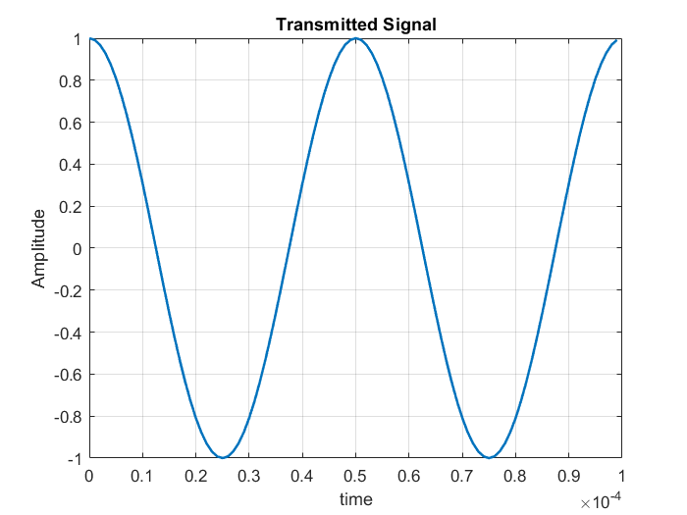For a signal with AOA of $30°$ and a ULA with $N_{r}=4$ antennas with spacing $d=\frac{λ}{2}$.

Figure 34 – Transmitted signal

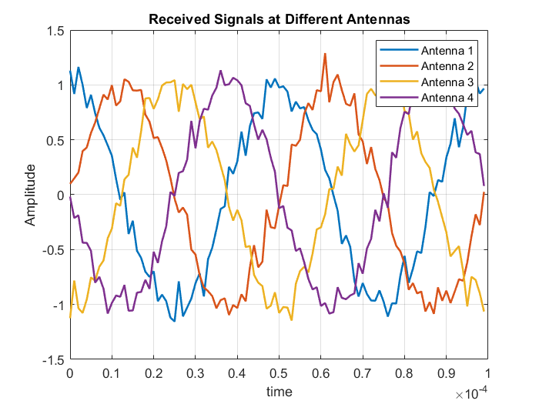

Figure 35 – Received signals at the ULA

Recall the weights for the delay and sum beamforming are

$w=e^{-j2πdksin(θ) }$ (20)

$Y=w^{H}.X$ (21)

$w$: weights vector of size $N_{r}×1$

$Y$: The beamformed signal ($1×N$) where N is the number of samples.

Notice that in figure (36) the amplitude of the signal is multiplied by 4 which is the number of antennas (number of signals delayed and summed) which shows the beamforming effect.

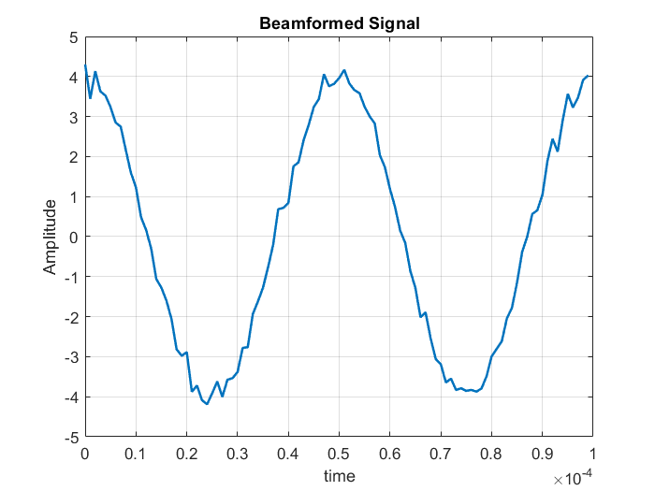

Figure 36 – Delay and sum beamformed signal

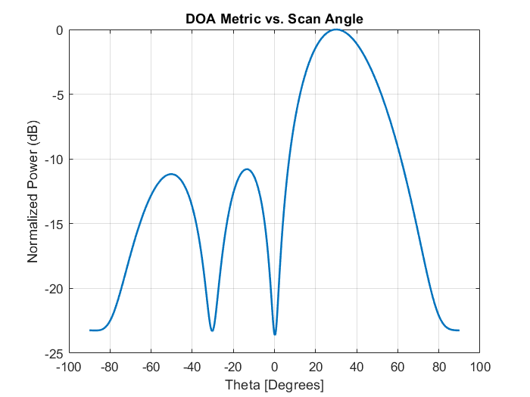Performing the DOA at thetas from $-90° to 90°$ yields the following results

Figure 37 – Delay and sum DOA metric rectangular plot

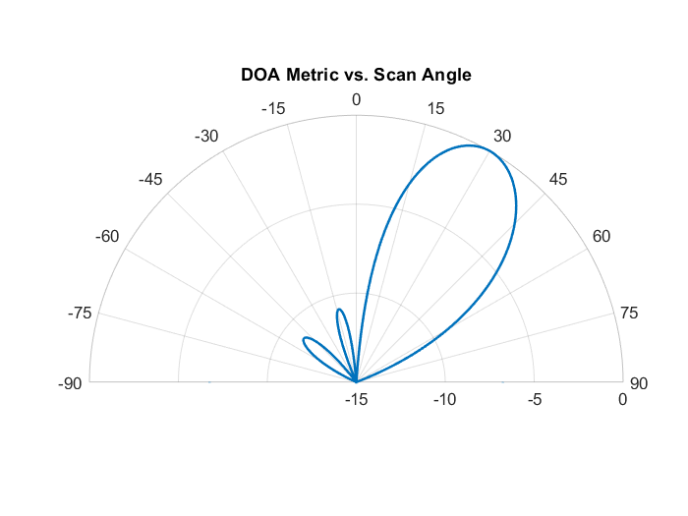

Figure 38 – Delay and sum DOA metric polar plot

For determining the direction of arrival, we simply calculate the variance (power) of the received signal at each scan angle and save the results. The scan angle which corresponds to the highest variance is our angle of arrival. We multiply the weights by the received signal at each scan angle then calculate the variance of the beamformed signal generated at the chosen scan angle and after iterating at all the scan angles we chose the one with the highest variance which is a simple process on MATLAB.

Figure 39 – MATLAB DOA calculation

**3.2 MVDR**

For a signal with AOA of $30°$ and a ULA with $N_{r}=4$ antennas with spacing $d=\frac{λ}{2}$.

Figure 40 – Transmitted signal



Figure 41 – Received signals at the ULA

Recall the weights of the MVDR beamformer are

$w_{mvdr}=\frac{R^{-1}.s}{s^{H}.R^{-1}.s}$**(30)**

$w$ is the Beamformer weighting that will produce the recovered signal.

$R$ is an $N_{r}×N_{r}$ sample correlation matrix.

$s$ is the steering vector with size $N_{r}×1$.

The beamformed signal after applying the weights and normalization is depicted in figure (42).

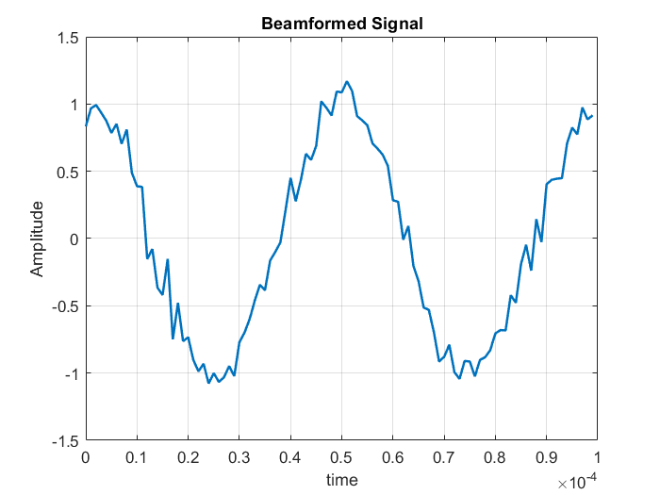

Figure 42 – MVDR beamformed signal

Performing the DOA at thetas from $-90° to 90°$ yields the following results

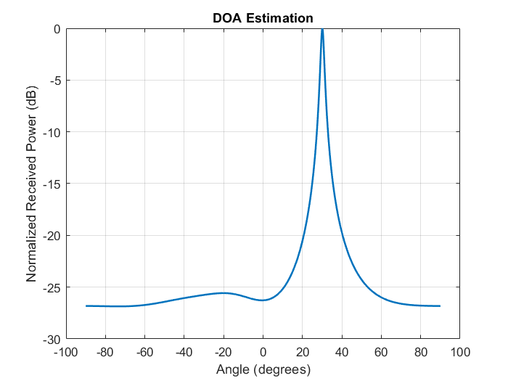

Figure 43 – MVDR DOA metric rectangular plot

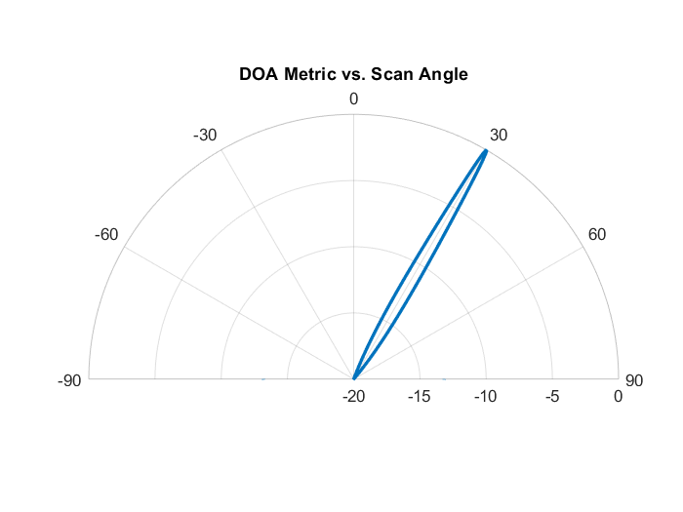

Figure 44 – MVDR DOA metric polar plot

From figures (43) and (44) we can see that the MVDR produces very sharp and directive beams.

****For determining the direction of arrival, we simply calculate the variance (power) of the received signal at each scan angle and save the results. The scan angle which corresponds to the highest variance is our angle of arrival. We multiply the weights by the received signal at each scan angle then calculate the variance of the beamformed signal generated at the chosen scan angle and after iterating at all the scan angles we chose the one with the highest variance which is a simple process on MATLAB.

Figure 45 – MATLAB DOA calculation

**3.3 Delay and sum Vs MVDR comparison**

comparing the performance of delay and sum vs MVDR:

We simulated 3 signals at three AOAs $θ_{1}=20° , θ_{2}=25° , θ_{3}=-40°$ and to make things more interesting we chose the first two signals to arrive at two closely separated AOAs ($20° and 25°$) and we also chose the power of the third signal (arriving at $-40°$) to be 10 times less the power of the first 2 signals.

The three signals are arriving at a ULA with $N_{r}=8$ antennas with spacing $d=\frac{λ}{2}$.

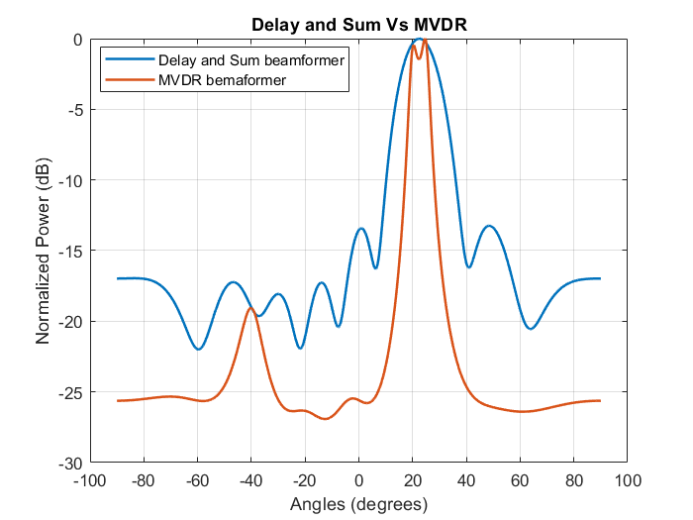

Figure 46 – Delay and sum Vs MVDR DOA metric rectangular plot

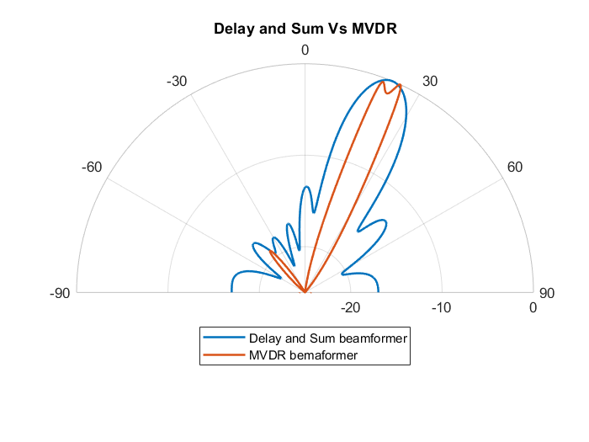

Figure 47 – Delay and sum Vs MVDR DOA metric polar plot

From figures (46) and (47) we can see that the performance of MVDR is a lot better than the performance of the delay and sum because

1. MVDR is more directive (the beam is more concentrated).
2. MVDR was able to detect and distinguish between the two signals arriving at the two close AOAs ($20° and 25°$) but delay and sum was not able to distinguish between them.
3. MVDR was able to detect the low power signal because its power level was higher than the side lobes level but delay and sum was not able to distinguish between the low power signal and its side lobes.

**3.4 LCMV**

To model the performance of LCMV we need to simulate multiple SOIs and interferers.

For our model we have interferers coming at AOAs of $-60° , -30° , 0° and 45°$ and two SOIs coming at AOAs of $-45° and 30°$.

The signals are arriving at a ULA with $N_{r}=8$ antennas with spacing $d=\frac{λ}{2}$.

Recall the weights of the LCMV beamformer are

$w_{lcmv}=R^{-1}C{\left[C^{H}R^{-1}C\right]}^{-1}f$ (31)

$R$ is an $N×N$ sample correlation matrix.

$C$ is a $N_{r}×n$ matrix comprising of steering vectors at the AOAs of $(n)$ SOIs and interferers.

$f$ the desired response vector. The vector  for a particular row takes the value of 0 when the corresponding steering vector is to be nulled, and takes a value of 1 when we want a beam pointed at it.

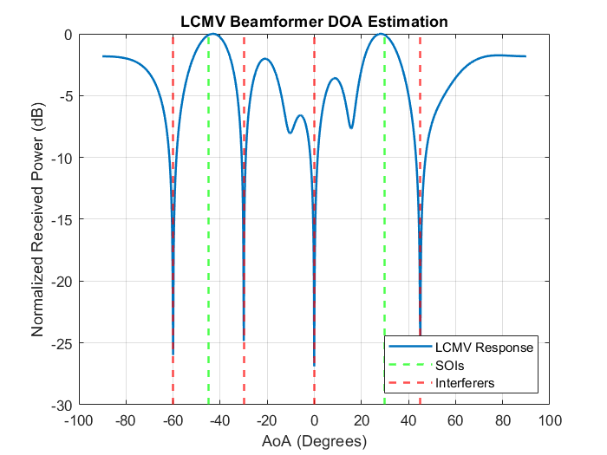

Figure 48 – LVMV DOA metric rectangular plot

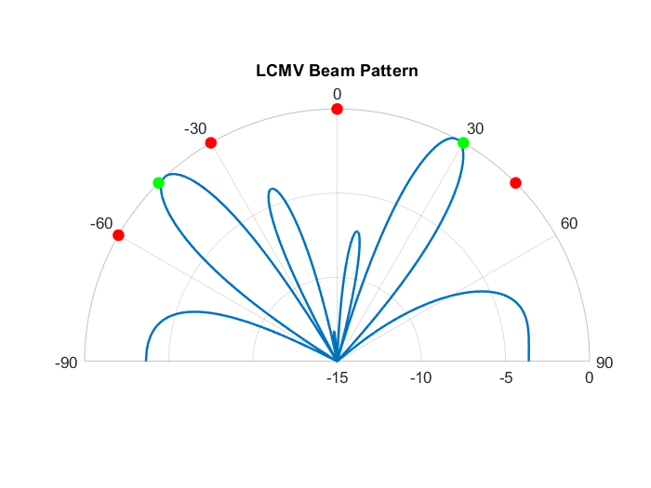

Figure 49 – LCMV DOA metric polar plot

From figures (48) and (49) we can seethatLCMV beamformer is a powerful tool that can be used to suppress interference and noise from multiple directions while simultaneously enhancing the signal of interest from multiple directions but the performance of the LCMV degrades near the edges of the antenna.

**3.5 MUSIC Algorithm**

For our model we have three SOIs coming at AOAs of $20° , 25° and-40°$ and we assume that the receiver knows the number of the signals arriving.

The signals are arriving at a ULA with $N_{r}=4$ antennas with spacing $d=\frac{λ}{2}$.

Recall for determining the AOAs in MUSIC

$θ=argmax(\frac{1}{s^{H}V_{n}V_{n}^{H}s})$ (36)

Where:

$V_{n}$ is the noise sub-space eigenvectors (a 2D matrix).

$s$ is the steering vector

argmax operator finds the angle $θ$ at which the MUSIC spectrum is maximized.

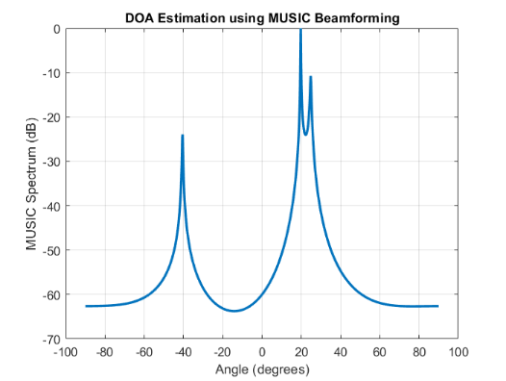

Figure 50 – MUSIC DOA metric rectangular plot

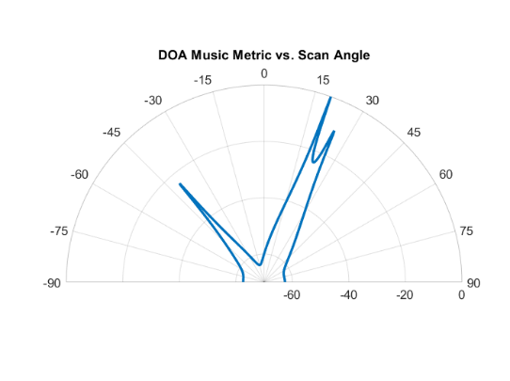

Figure 51 – MUSIC DOA metric polar plot

From figures (50) and (51) we can see that we get very precise results from MUSIC.

What if we had no idea how many signals were present?

We can figure this out by sorting the eigenvalue magnitudes from highest to lowest, and plot them.

The eigenvalues associated with the noise-subspace are going to be the smallest, and they will all be around the same value, so we can treat these low values like a “noise floor”, and any eigenvalue above the noise floor represents a signal.

An example of an 8-element array and 3 input signals.

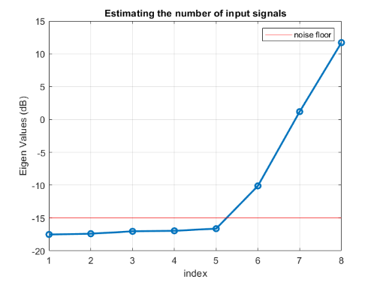

Figure 52 – MUSIC number of input signals estimation

By investigating figure (52), we can see that three points are above the noise floor which represents the number of received signals.

Underestimating the number will lead to missing signal(s) while overestimating will only slightly hurt performance as depicted in figures (53) and (54).

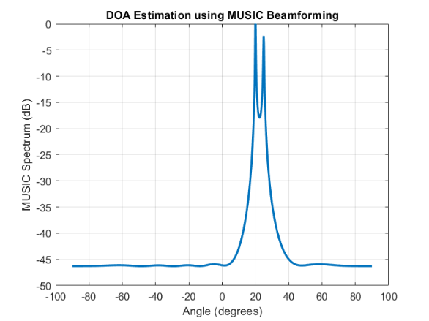

Figure 53 – Underestimating the number of input signals

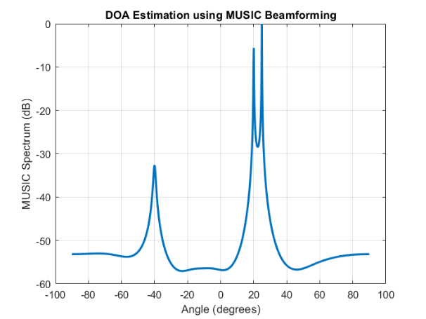

Figure 54 – Overestimating the number of input signals

An experiment worth trying with MUSIC is to see how close AOAs of two signals can be while still being able to distinguish between them, sub-space techniques are especially good at that.

For three signals separated apart by 4 degrees ($AOAs at 20°,24° and 28°$)

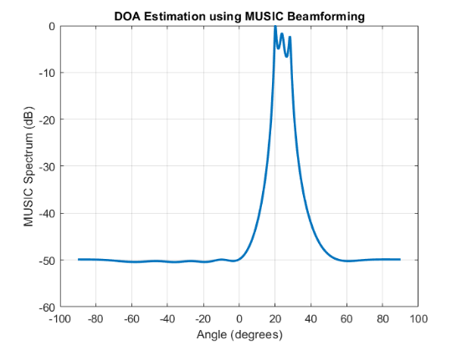

Figure 55 – MUSIC for closely separated signals

From figure (55) we can see that we are able to distinguish between the different peaks despite being very close to each other.

**3.6 ESPRIT Algorithm**

For our model we have three SOIs coming at AOAs of $20° , 25° and-40°$ and we assume that the receiver knows the number of the signals arriving.

The signals are arriving at a ULA with $N_{r}=4$ antennas with spacing $d=\frac{λ}{2}$.

To determine directions of arrival, it is necessary to:

* Achieve the decomposition in singular value of the data covariance matrix where is the number of observations.
* Estimate the dimension of the signal subspace (40).
* Separate the eigenvectors corresponding to the signal subspace and form the matrices of sub-networks $E_{1}$ and $E_{2}$.
* Estimate the rotation operator $Ψ$ (45).
* Calculate the eigenvalues $λ_{1}, λ_{2},…,λ_{k}$ of the matrix $Ψ$ (46).
* Finally, calculate the AOAs (47).

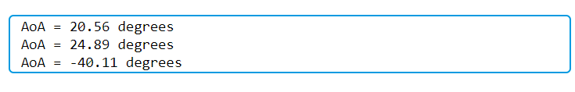

Figure 56 – ESPRIT DOAs MATLAB calculation

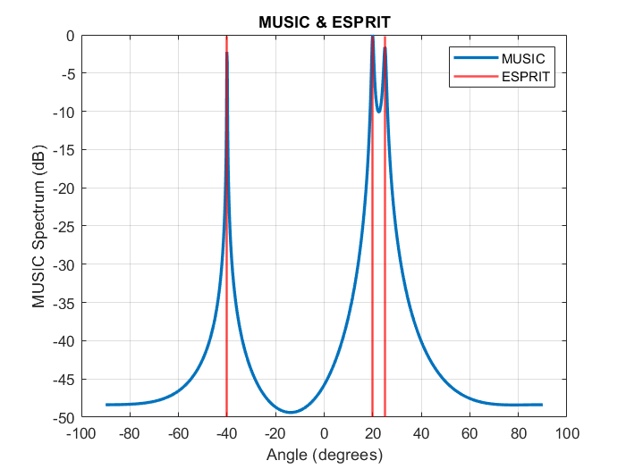

Figure 57 – MUSIC & ESPRIT DOA metric

From figure (57) we can see that the performance of the ESPRIT is very similar to the performance of the MUSIC.

**Ch 4: Conclusion and Future work**

**4.1 Conclusion**

This thesis has explored the integration of Massive MIMO, digital beamforming, and mm-Wave technologies to address the growing demands of modern wireless communication systems. We demonstrated how beamforming can enhance signal clarity and capacity in high-density environments.

The MATLAB simulations provided a comparative analysis of various beamforming techniques, showcasing the strengths of MVDR in mitigating interference and the capabilities of MUSIC in accurately estimating the direction of arrival (DOA). These results underline the pivotal role of digital beamforming in achieving the spectral efficiency and high data rates required for 5G and beyond.

Given its simplicity and suitability for hardware implementation, the delay-and-sum beamforming technique was selected for practical deployment. Its straightforward architecture allows for efficient processing with minimal hardware complexity, making it an ideal candidate for integration into real-world systems. Furthermore, future work will include a thorough investigation of the system surrounding the beamforming block to ensure seamless integration and optimization within the system.

In conclusion, this work contributes to the foundation for developing efficient and scalable wireless communication systems. By combining innovative signal processing techniques with emerging technologies, we can pave the way for robust, high-capacity networks capable of supporting the ever-increasing demands of the digital era.

**4.2 Future Work**

The first phase of this project involved a comprehensive literature review of MIMO and beamforming techniques, providing a solid foundation for understanding these concepts and identifying approaches relevant to system design. Moving forward, the focus will shift to the modeling and design of the system surrounding the beamforming block in both the transmitter (Tx) and receiver (Rx).

The next steps include developing models that represent the Tx and Rx systems, with particular attention to how the delay-and-sum beamforming technique can be implemented in hardware due to its simplicity and efficiency.

As a priority, the design and optimization of the Rx system will be undertaken first, ensuring its seamless integration with the beamforming block. This phase will involve analyzing hardware constraints, optimizing algorithms for real-time processing, and evaluating system performance in varying conditions.

**Proposed RX design**

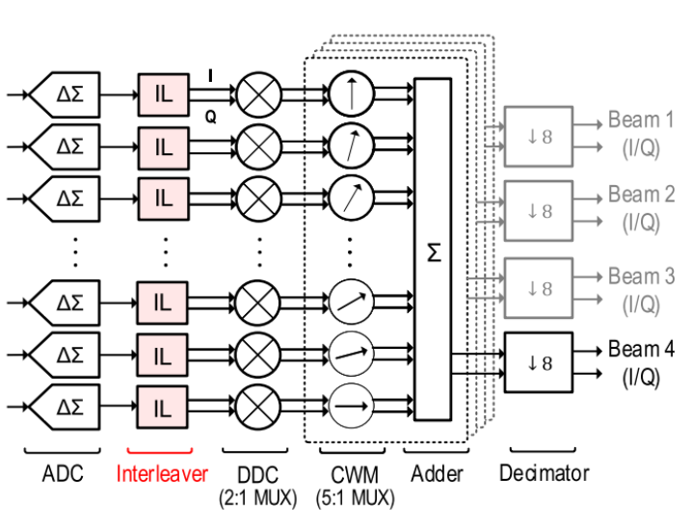The block diagram of the system:

Figure 58- Rx-block diagram [[Source](https://ieeexplore.ieee.org/document/8271864)]

**Blocks overview**

**1- Interleaver**

The interleaver is critical technique in digital signal processing systems, especially for beamforming and communication applications. Its primary function is to reduce the clock rate, which in turn lowers power consumption and simplifies digital circuitry. By interleaving, the data rate from the ADC is reduced, enabling more efficient downstream processing.

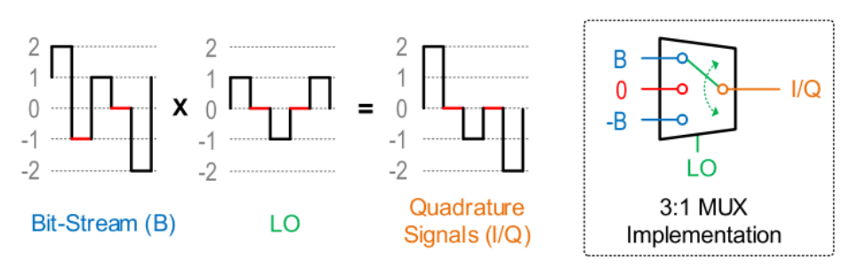In the context of digital down-conversion, the interleaver achieves simplification by performing an initial decimation by two. This reduces the rate at which the subsequent stages of the DDC operate. Before interleaving, the DDC used a 3:1 multiplexer (MUX) driven by the local oscillator, involving sine and cosine wave values of -1, 0, and 1. With the interleaver, the circuit is simplified to use a 2:1 MUX with only -1 and 1 as LO values. This improvement optimizes power efficiency and minimizes the complexity of the system architecture as illustrated in figure (60) below. [22]

Figure 59- DDC before adding the interleaver [[Source](https://ieeexplore.ieee.org/document/8271864)]

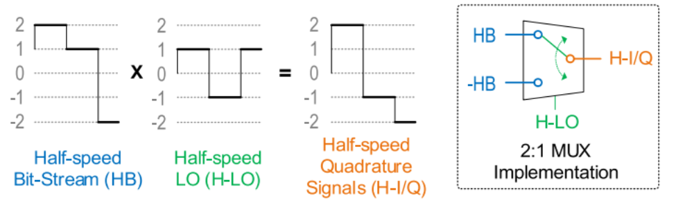

Figure 60- DDC after adding the interleaver [[Source](https://ieeexplore.ieee.org/document/8271864)]

**2- Digital Down Converter (DDC)**

The DDC brings a signal from the intermediate frequency (IF) band to the baseband by multiplying the input signal with sine and cosine waves to generate in-phase (I) and quadrature (Q) components. In this design, the sine and cosine waves are sampled at four times the carrier frequency ($f_{c}=f_{s}∕4$) resulting in simple sample values of -1, 0, and 1.

The simplified DDC architecture benefits from the interleaver by further minimizing the required resources. Multiplication operations in the DDC are reduced to a series of multiplexing operations, making the overall system more efficient​. [22]

**3- Complex Weight Multiplexing (CWM)**

The Complex Weight Multiplication (CWM) block is a core component in beamforming systems, designed to enhance signal strength in a specific direction by aligning and summing signals from multiple antennas. It processes I & Q branches (In-phase and Quadrature components) received from a Digital Down Converter (DDC), which converts signals from Intermediate Frequency (IF) to Baseband Frequency. The block applies phase shifts to each antenna's signal based on the desired beam direction, calculated using the formula

$Δϕn =2πf⋅Δtn​$ (49)

Where $Δtn​$ is the time delay derived from antenna spacing and the target angle as illustrated in figure (61).

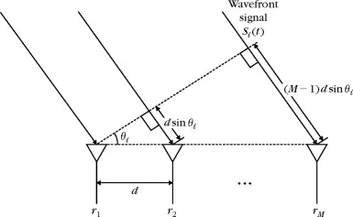

Figure 61- Uniform Linear Array with signal wavefront [[Source](https://medium.com/@itberrios6/introduction-to-beamforming-part-1-92767408f483#4ca6)]

Additionally, amplitude weighting (beam tapering) is applied using window functions (e.g., Hamming Window) to control sidelobe levels and beamwidth, resulting in a weighted signal for each antenna.

After applying phase shifts and amplitude weights, the CWM block sums the adjusted signals to produce a focused beam in the desired direction. This process amplifies the signal in the target direction while attenuating signals from other directions, improving overall signal quality and directivity. The block's functionality is illustrated in the document's block diagrams and mathematical formulas, showing how phase shifts and amplitude adjustments are calculated and applied. The CWM block is essential for achieving beamforming in applications like Wi-Fi and 5G, where directional signal enhancement is critical for communication efficiency. [25]

**4- Decimation Filters**

The decimation filter is a key component in digital signal processing (DSP), used to reduce a signal's sampling rate by an integer factor M. It consists of two main steps: anti-aliasing filtering and down-sampling. First, a low-pass filter bandlimits the signal to (Fs / 2M) to prevent aliasing, ensuring the Nyquist criterion is met. Then, the signal is down-sampled by retaining every M-th sample, reducing the sampling rate from Fs to Fs / M. [24]

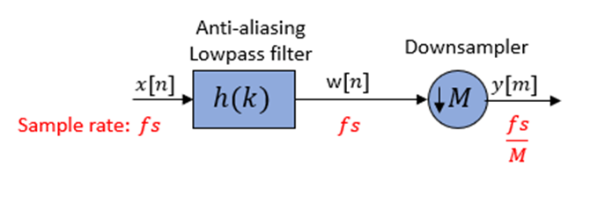

Figure 62- Decimation Filter [[Source](https://www.mathworks.com/help/dsp/ug/overview-of-multirate-filters.html)]

**Why we use decimation**

Decimation reduces the computational resources and power needed for processing and storing the signal as it allows DSP blocks to operate at much slower frequencies.

Also the Sigma-Delta ADC oversampled the received signal, a decimation filter is needed to down sample the oversampled signal and filter the bandwidth with an anti-aliasing low pass filter. The decimation filter does not affect the SNR, its role is to down-sample the oversampled signal and filter the bandwidth.

The Receiver consists of two decimation filters, one for the I (in phase) signal and the other for the Q (out of phase) signal.

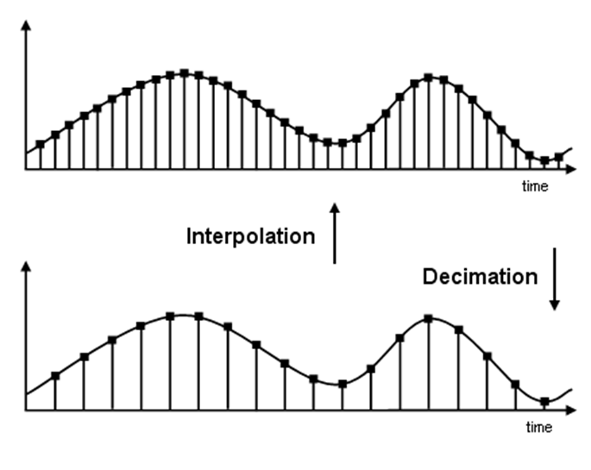

Figure 63- Interpolation vs Decimation [[Source](https://www.mathworks.com/help/dsp/ug/overview-of-multirate-filters.html)]

**References**

[1] Marzetta, T. L., Larsson, E. G., Yang, H., & Ngo, H. Q. (2016). Fundamentals of Massive MIMO. Cambridge University Press.

[2] HFCL. (n.d.). Beamforming: Glossary Definition. <https://io.hfcl.com/glossary/beamforming>

[3] Wikipedia. (n.d.). Phased Array. <https://en.wikipedia.org/wiki/Phased_array>

[4] PySDR. (n.d.). Direction of Arrival (DOA) estimation. <https://pysdr.org/content/doa.html>

[5] Berrios, I. T. (2020, August 9). Introduction to Beamforming (Part 1). Medium. [https://medium.com/@itberrios6/introduction-to-beamforming](https://medium.com/@itberrios6/introduction-to-beamforming-part-1-92767408f483)

[6] Sanny Telecom. (n.d.). MIMO Antennas vs. SISO Antennas. <https://www.sannytelecom.com/mimo-antennas-vs-siso-antennas/>

[7] Huawei Technologies. (n.d.). MIMO Overview. <https://info.support.huawei.com/info-finder/encyclopedia/en/MIMO.html>

[8] Gao, X., Zhang, Z., & Hu, X. (2018). Massive MIMO: An Overview of Challenges and Opportunities. IEEE Communications Magazine, 56(3), 23–29. <https://ieeexplore.ieee.org/abstract/document/8455114>

[9] Salehi, N., Ashkezari, M. D., & Kiani, F. (2020). Role of wireless communication technologies in COVID-19 detection and prevention. Journal of Environmental Health Science and Engineering, 18(2), 991–998. <https://pmc.ncbi.nlm.nih.gov/articles/PMC7284607/>

[10] Wireless Pi. (n.d.). What is the Difference Between Analog, Digital, and Hybrid Beamforming? <https://wirelesspi.com/what-is-the-difference-between-analog-digital-and-hybrid-beamforming/>  
[11] YouTube. (2022, September 25). Understanding Beamforming for Wireless Systems. <https://youtu.be/9WxWun0E-PM?si=HrSbVpaxWXL1oYjl>  
[12] Stutzman, W. L., & Thiele, G. A. (2013). Antenna Theory and Design. Wiley.  
[13] Li, X., & Zhang, Z. (2018). Comparative Study of High-Resolution Direction-of-Arrival Estimation Algorithms for Array Antenna System. Wireless Personal Communications, 101, 1–12. <https://link.springer.com/article/10.1007/s11277-018-6006-9>  
[14] Cadence Design Systems. (n.d.). Fundamentals of MIMO Communication in Wireless Systems. <https://resources.system-analysis.cadence.com/blog/fundamentals-of-mimo-communication-in-wireless-systems>  
[15] Profolus. (2023). Massive MIMO Explained: Advantages and Disadvantages. <https://profolus.com/topics/massive-mimo-explained-advantages-and-disadvantages/>  
[16] Verkotan. (2023). MIMO, MU-MIMO, and Massive MIMO: Testing at Verkotan. <https://verkotan.com/2023/mimo-mu-mimo-and-massive-mimo-mimo-testing-at-verkotan/>  
[17] Cho, Y. S., et al. (2010). MIMO-OFDM Wireless Communications with MATLAB. Wiley.  
[18] Commsbrief. (n.d.). MIMO in LTE: What is Multiple Input Multiple Output in 4G? [https://commsbrief.com/mimo-in-lte-what-is-multiple-input-multiple-output-in-4g](https://commsbrief.com/mimo-in-lte-what-is-multiple-input-multiple-output-in-4g/#:~:text=MIMO%2C%20or%20Multiple%20Input%20Multiple,link%20quality%20and%20data%20rates)  
[19] ABI Research. (2023). 5G Massive MIMO: Enhancing Data Capacity and User Throughput. [https://www.abiresearch.com/blog/massive-mimo](https://www.abiresearch.com/blog/massive-mimo#:~:text=5G%20massive%20MIMO%20is%20a,data%20capacity%20and%20user%20throughput)

[20] Nokia Bell Labs. (2015). Massive MIMO: An introduction. IEEE Communications Magazine. <https://ieeexplore.ieee.org/document/7064850>

[21] Verkotan. (2021). Beamforming antennas: How they work and are tested. Verkotan Blog. <https://verkotan.com/2021/beamforming-antennas-how-they-work-and-are-tested/>

[22] Pao, H., Bai, Y., & Luh, L. (2018). A 16-Element 4-Beam 1 GHz IF 100 MHz Bandwidth Interleaved Bit Stream Digital Beamformer in 40 nm CMOS. IEEE Transactions on Circuits and Systems I: Regular Papers, 65(12), 4215–4227. <https://ieeexplore.ieee.org/document/8271864>  
[23] Hunter Communications. (n.d.). Digital Down Converter (DDC) Theory. <https://hunteng.co.uk/support/ddctheory.htm>  
[24] MathWorks. (n.d.). *Overview of Multirate Filters*. <https://www.mathworks.com/help/dsp/ug/overview-of-multirate-filters.html>

[25] Jaehun Jeong.(2015).IF-Sampling Digital Beamforming with Bit-Stream Processing (Doctoral dissertation, University of Michigan). Deep Blue. <https://deepblue.lib.umich.edu/bitstream/handle/2027.42/116778/jaehun_1.pdf>

[26] Khan, M. Z. U., Malik, A. N., Zaman, F., & Qureshi, J. M. (2019). Robust LCMV beamformer for direction of arrival mismatch without beam broadening. Wireless Personal Communications, 104, 21–36. <https://doi.org/10.1007/s11277-018-6006-9>

[27] CommsBrief. (2021). Difference Between MIMO, SISO, SIMO, and MISO Antenna Systems. <https://commsbrief.com/difference-between-mimo-siso-simo-and-miso-antenna-systems/>

**EDITS**  
mmwave.

Edit source links to numbers.